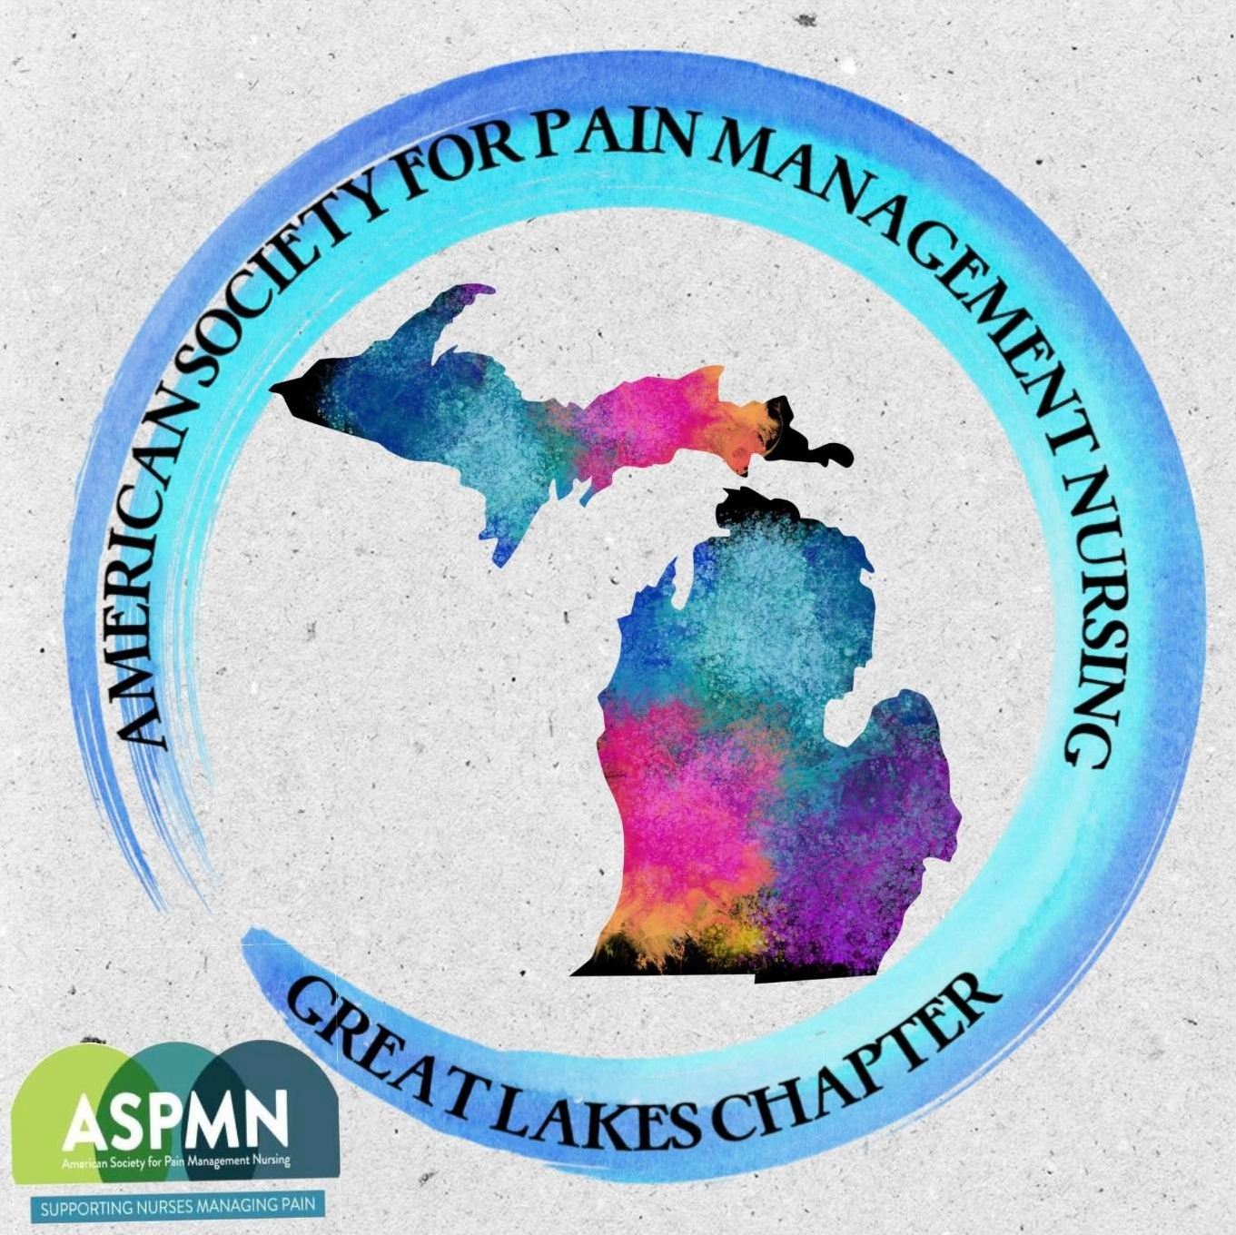
Meloche Memorial Scholarship Fund
2222 W. Grand River Ave. Suite A Okemos, MI 48864
MelocheMemorialFund@gmail.com
https://glcaspmn.nursingnetwork.com/

To those who knew and loved Kathy, or others interested in honoring her memory,
The purpose of this scholarship fund is to honor Kathy’s passion and commitment to lifelong learning and compassionate care for patients experiencing pain. She was active in the pursuit of translating evidence into practice at local, state and federal levels. Kathy was a founding member of our local chapter of ASPMN, called the Great Lakes Chapter. Scholarship funds will be provided for eligible ASPMN-GLC members to put towards attendance at the national ASPMN conference or towards the pursuit of certification in pain management. For anyone interested in tracking the progress of our fundraiser, please visit our website at https://glcaspmn.nursingnetwork.com/
For those interested, there are two ways to make a contribution to Kathy’s memorial scholarship fund:
- Access Zelle, a mobile banking app. If your bank or credit union doesn’t offer Zelle yet, you can download the Zelle app to get started. To donate using Zelle, search using our scholarship email address: MelocheMemorialFund@gmail.com
  - Please note, the Zelle app requires a person versus organizations name and therefore the immediate notification you receive from Zelle may appear to have made a donation to our current ASPMN-GLC President, Ashley Meyers, and will also indicate the name of the scholarship fund as well. This Zelle transfer is made directly to the Comerica scholarship checking account indicated below:
2. Make a direct donation to the Meloche Memorial Scholarship Checking Account at Comerica Bank; checking account number 1853433306
Each year, in January, a letter will be sent to every person that donated to the scholarship fund. The letter will indicate the amount of the donation, date, it was made to a 501c3 non-profit, educational entity.
Warm regards and appreciation,
Your name here
Kathy’s friend, fellow pain management nurse and ASPMN-GLC member

