AACN
CHARLES TOWNE CHAPTER
2024


Rising Together: AACN’s 2024 Theme

In 2024, the National Teaching Institute & Critical Care Exposition (NTI) celebrates its 50th anniversary. As AACN President Terry Davis (then president-elect) said in her NTI address, “Together, we are so extraordinary. What a profound sea change we’ve experienced. There’s more to come. Someone must drive that change. If not us, then who? Who do you trust with such profound responsibility? What happens next is too important to let others decide.”
“Rising together, we will lift each other up. Rising together, we will advance our journey. Rising together, we will manifest the future.”
~Terry Davis
Davis urged nurses to embrace and advance change by stepping into leadership roles and working toward shared governance. “We must share our care for each other,” she said. “As nurses, we recognize distress in others. Harder to see it in ourselves.” She also discussed her pioneering work in telemedicine, when “we stood tall and had great courage, despite the fact that many people did not want telemedicine, especially in the ICU. We had to have hard conversations to get to where we are today.” She encouraged the audience to lean into those uncomfortable conversations.
Rising Together we can help meet the needs of our teams, our patients and our families, Davis said. “Rising together, we will lift each other up. Rising together, we will advance our journey. Rising together, we will manifest the future.” If every nurse thinks of one change they can make, then “like a ripple in the ocean, that movement, that motion, that momentum will manifest and build into a wave that can touch every shore.”
To illustrate the interconnectedness of this year’s theme, Helen D’Souza designed original art. “The nurse is a bridge between the patient and the doctor, between the patient and their family, between illness and recovery,” D’Souza said. A golden braid forms a bridge to symbolize this connection.

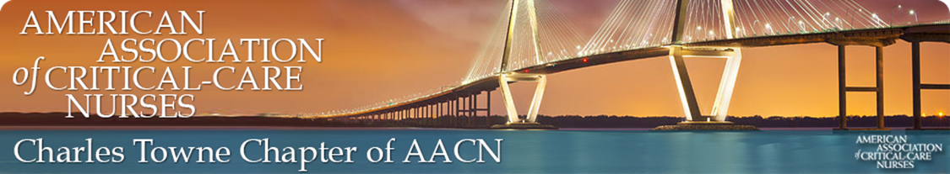
ANNUAL BOARD MEETING
Held on November 2, 2023 5:30PM
Updates from your Board
Welcome/Introductions
Board President Treasurer (Past)
Cynthia Steffen Laura Gallagher Pam Parker
Deanne Clark Past-President Secretary
Ginny Ledbetter Grace Rankin Caitlin Dennin
Pam Parker Treasurer Membership Chair
Kristina Johnson Melissa Wright
National/Chapter Requirements Completed August 15
>Charter Chapter Agreement signed 2023 and good through 2024/Charter Dues
>Annual Check Signer Form-Pam/Kristina/Laura
>Quarter 4 Financial Report-Pam/Kristina
>Annual Audit Form (fiscal year ending 06/30) - 2 Board Members to review
Financial Review – report from Pam and Kristina (handouts)

Membership
>Report
>National Database
>Nursing Network
Review Responsibilities and Accountabilities
>Power point presentation reviewed
Goals for the Year
>Educational Opportunities
>NTI Scholarships
>Community Service (suggestions: beach clean-up, donations, others?
>Fundraising
Upcoming Meetings [First Thursday of the Month]
December 7th – Holiday Gathering sponsored by Chapter (Marina Variety Store)
January 4th – sponsored by Medline
February 1st – sponsored by Chiesi
March 7th – sponsored by Inari
April 4th – sponsored by Sage/Stryker
Remember to check the Nursing Network website to be sure you’re following our Chapter updates and invites!
~Laura

