Rocky Mountain PeriAnesthesia Nurses Association

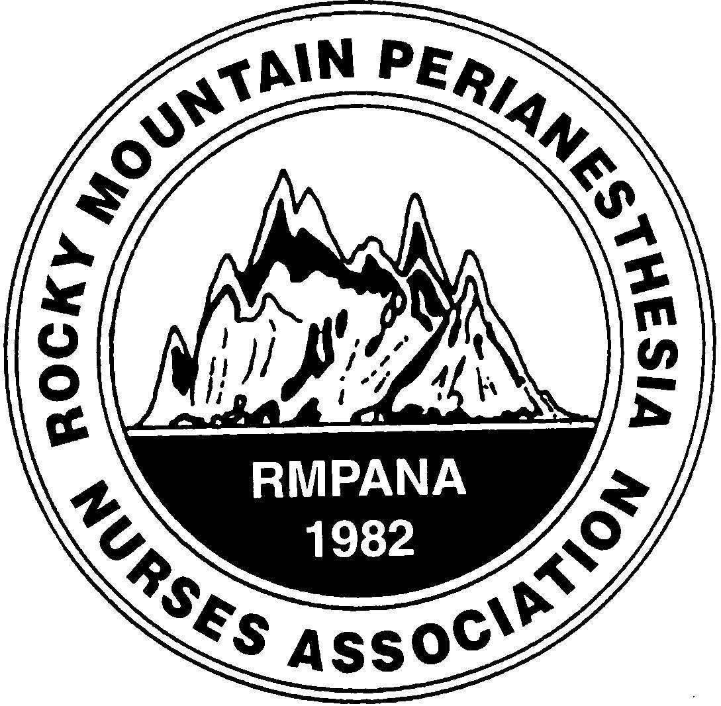

**Project C.U.R.E Community Project**

**Saturday, December 2, 2023**

**0900-1200 (text me if you plan to come at 0800)**

**Project C.U.R.E**

10377 E. Geddes Ave. Ste. 200, Centennial, Colorado

I-25 to East Dry Creek Rd—east exit to South Clinton Street; left (north) to East Geddes Street; right (east) to Project Cure on left side. (East of Maggiano’s Restaurant)

**WE ARE LIMITED TO 20!!**

**You MUST register online for this event:**

<http://denrmpana.projectcure.volunteerhub.com/>

Click on the link on the calendar

(copy Control C and paste Control V) if it does not work)

**Please register for this event even if you have registered before!**

**Additional Information:**

Nancy O'Malley:  303 437-5546 or nancyo44@aol.com

**Minimum age to volunteer: 14**

**(under 18 requires parent/legal guardian signed consent)**

**RMPANA members and guests are invited**

**We usually go out for lunch after–join us if you can!**

**Instructions for ALL PROJECT CURE VOLUNTEERS:**

**You need to register on the Project Cure prior to arrival at the warehouse. This is a liability requirement as well as a mechanism for monitoring volunteer hours to assist Project Cure with grant funding and reporting.**

**Event Date/Time:** Sat, December 2, 2023 from 9:00 AM - 12:00 PM  
  
**Event Name:** RMPANA   
  
**Attire:**Closed-toed shoes are required in the warehouse.

Dress WARM in the winter (still may be chilly in early May) – some of the warehouse is heated but it can be very chilly.

**Parking:** Park in the west lot; enter through the door that says Volunteer Entrance.

**Event Description:** You are invited to Deliver Health and Hope to the World!

Project C.U.R.E. was founded in 1987 to help meet the need for medical supplies, equipment and services around the world. Since its inception, Project C.U.R.E. has delivered medical relief to needy people in more than 120 countries. We will be sorting medical supplies for those who are in desperate need. This will be a fun, engaging and hands-on experience.

**Watch the video** to become familiar with Project C.U.R.E. and learn about the vital impact your volunteer experience creates. [**Project CURE Video:**](https://www.youtube.com/watch?v=eX1VFsZw5TI%20)

**https://www.youtube.com/watch?v=eX1VFsZw5TI**

If the door is locked, call me on my cell-303-437-5546.

Let me know if you have any problems registering or questions.

