At the end of the program, participants will be able to:  - Discuss the impact of social determinants of health (SDOH) on individual and population health.  - Define the mission, vision, and goals of the Nurse Advocacy Center for the Undeserved (NACU)  - Discuss NKU’s School of Nursing community/population health nursing curriculum to prepare the next generation of nurses in supporting health equity.  - Identify NACU needs and ways to get involved in the program and support the underserved.  - Identify why the Patient Experience is important.  - Understand the history of the Patient Experience.  - Discuss the importance and difference between the Press Ganey and Hospital Consumer Assessment of Healthcare Providers and Systems scores.  - Explain foundational best practice for the Patient Experience.  - Understand legal issues involving nurses: electronic charting, patient advocacy, social media.  - To educate on the stereotypes and stigmas surrounding substance use and how to discuss drug addiction.  - Identify signs and symptoms of adverse reactions to anesthesia related to substance use.  - Discuss the importance of ASPAN and how the organization benefits your practice as a Perianesthesia Nurse  - Discuss the strategic planning in presenting topics during state and national conferences.  - Discuss the importance of the Representative Assembly  - Understand the role of the Nursing Corp and ways to support and get involved. |  |  |  | All-Virtual Format  Via  Zoom
All-Virtual Format
Via
Zoom

Objectives
Kentucky Society of Perianesthesia Nurses
(KSPAN)
Fall Seminar
November 11, 2023
8:00 – 8:15 Welcome Teresa Dudley, MSN, RN, CPAN KSPAN President
8:15 – 9:15 Northern Kentucky University Nurse Advocacy Center for the Underserved (NACU) Jennifer Hunter DNP, MSN, BSN, RN Assistant Professor/BSN Program Director of the Nurse Advocacy Center for the Underserved (NACU) Northern Kentucky University, School of Nursing
9:15 – 9:30 Break
9:30 – 10:30 Legal Issues in Nursing Joseph A. Rectenwald Associate General Counsel – Risk Management St. Elizabeth Healthcare
10:30 – 10:45 Break
10:45 – 11:45 Patient Experience: Why it Matters Katina Turner BSN-RN, CAPA Chair Perioperative Patient Experience Council St. Elizabeth Healthcare
11:45 – 12:15 Lunch (KSPAN Business Meeting)
12:15 – 1:15 Nursing Corp Elizabeth Schoulties MSN, RN, NPD-BC, CPAN Education Specialist, Simulation Center Organizational Development St. Elizabeth Healthcare
1:15 – 1:30 Break
1:30 – 2:30 What ASPAN is to Perianesthesia Nurses Teresa Dudley, MSN, RN, CPAN KSPAN President
2:30 – 2:45 Break
2:45 – 3:45 Caring for the Patient with Substance Use Disorder LaVetta Carney MSN-RN, CAPA
3:45 – 4:00 Closing and Evaluations

CE application in process

https://kspan.nursingnetwork.com/
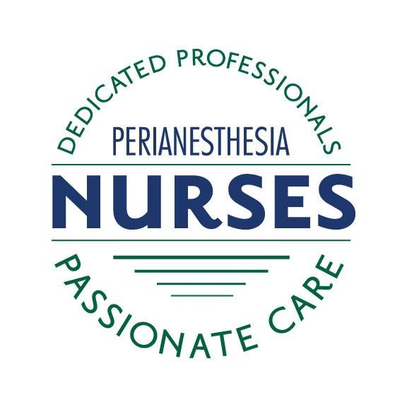  Target Audience  This program is for all perianesthesia nurses and those nursing students interested in pursuing a career in perianesthesia nursing.  Program Overview  The purpose of this program is to provide educational information to further develop the knowledge base of perianesthesia nurses.  KSPAN BOD  Teresa Dudley MSN, RN, CPAN President  Elizabeth Steffen, BSN, RN, CAPA President Elect  Donna Hagan BSN, RN, CPAN Secretary  Pam Malast BSN, RN, CPAN Treasurer  Lisa Casnellie MSN, BSN, RN, CAPA, CNOR  Lavetta Carney SN-Ed, RN, CAPA  Patricia Cooper MSN, RN, CPAN  Debra Payne MSN, RN, CAPA  Janice Newton MSN, RN  Raymond Young DNP, RN, BBA, NEA-BC, CPAN, CAPA  Hot Topics: In Nursing and our Communities  Please join us, virtually, for the 2023 KSPAN Fall Conference. This is a wonderful opportunity for knowledge sharing, fellowship, and networking. We are looking forward to seeing you online. |  |  |  | REGISTER ONLINE AT: kspan.nursingnetwork.com  $55.00 Members and Non-Members  $20.00 Students  Special Thanks  St. Elizabeth Healthcare  Miscellaneous  KSPAN reserves the right to substitute speakers if necessary.  You will receive confirmation of meeting registration.

Continuing Education
The application for contact hours is in process through St. Elizabeth Healthcare, an accredited provider through ANCC.
Speaker program handouts will be available for download on the KSPAN website at:
www.kspan.nursingnetwork.com

