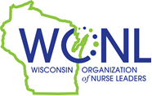
Educational Scholarship Program
Bachelor of Science in Nursing (BSN) or Associate Degree Program

Enrollment Verification Form

Student’s Name:

WI RN License Number:

Name of School:

Enrollment Verification Statement:

I verify that the student named above is enrolled in my institution’s ADN or BSN program for the 2023-2024 academic year.

School Representative’s Name Electronic Signature

Title Date

