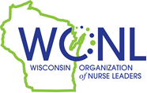
2023 Educational Scholarship Program
Advanced Leadership Degree: MSN, MBA, MHA, MSOL, PhD or DNP

Enrollment Verification Form

Student’s Name:

WI RN License Number:

Name of School:

Enrollment Verification Statement:

I verify that the student named above is enrolled in the following program at my institution for the 2023-2024 academic year:

MSN MBA MHA

MSOL DNP PhD

School Representative’s Name Electronic Signature

Title Date

