Please Join Us for an Educational Program

***Provided by:***



***Polyp Management and Electrosurgery***

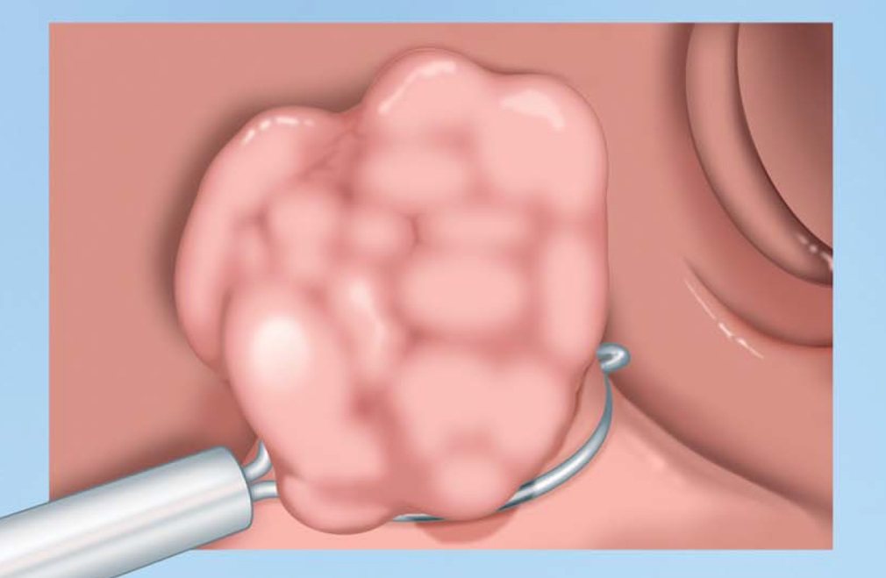

**Course Content:**

I. Polyp Types

A. Classification

B. Morphology

II. Endoscopic Resection

A. Basic Polypectomy Cold vs. Hot

B. EMR

C. ESD

D. Submucosal Injection

E. Evidenced based practices

III. Electrosurgery

A. Principles and properties

B. Current Density

C. Waveforms

D. Clinical Safety

***Location: Park Event Center***

***500 Division St, Waite Park, MN***

***Date / Time: 10/07/2023***

***6:00***

***Presented By: Rhonda DelCampo, BSN, RN, CGRN & Jeff Tait, Sales representative***

***RSVP:*** [***Jeff.Tait@erbe-usa.com***](mailto:Jeff.Tait@erbe-usa.com) ***by 10/1/2023***

There is no fee for attending this contact hour educational program***.*** Provider approved by the California Board of Registered Nursing, Provider # 15256, for **1.0 Contact Hours**. As mandated by the California Board of Registered Nursing, the licensee must retain this certificate for a period of four years after the course concludes. According to the criteria of the American Board of Certification for Gastroenterology Nurses (ABCGN), **1.0 hours** earned in this activity are considered GI Specific for the purpose of recertification by contact hours through the ABCGN. ABCGN tracking #: **ABCGN22_018**