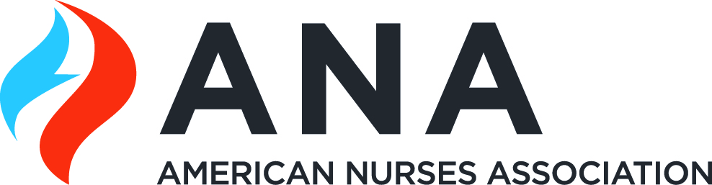 | 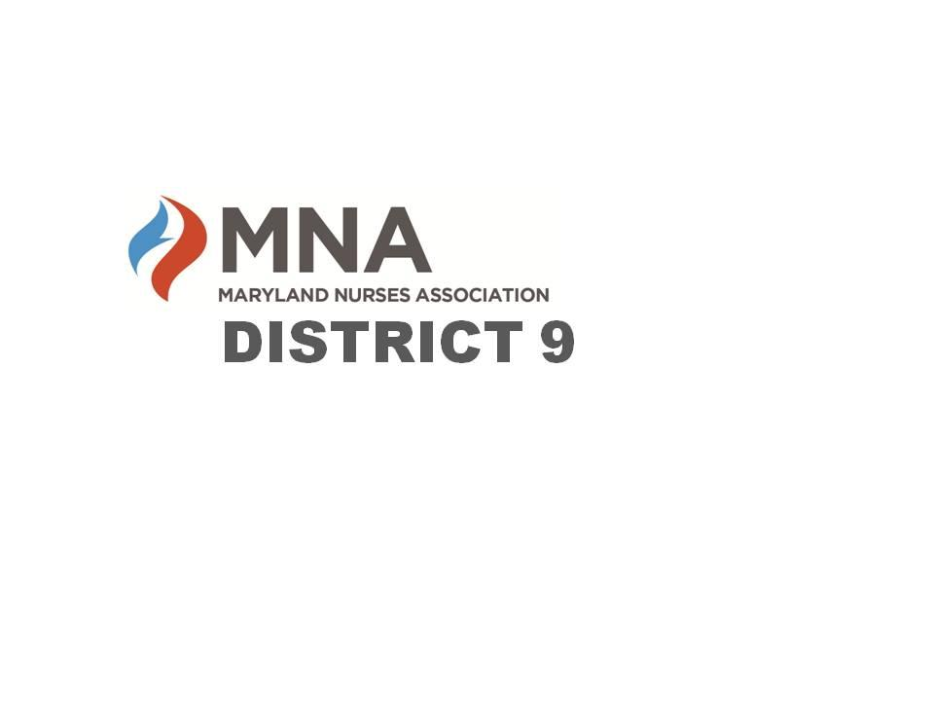
2023 MNA District 9 Annual Fall Dinner Meeting

“From Surviving to Thriving with Mental Fitness”
presented by:
Linda Roszak Burton ACC, BBC, BS

Wednesday, September 20, 2023
5:30pm – 8pm
Dinner will be provided by Flavaz Catering

The College of Southern Maryland Regional Hughesville Campus
6105 Foster Lane, Hughesville, MD 20637
Health & Sciences Room 106
Everyone is welcome! RSVP by September 13th
Cost: $20

Scan the QR code to register, or send payment via
Venmo: @Kathleen-Miller-219 or Zelle: 301-520-5461 (Kathleen Miller)
Visit our website or Facebook page
https://www.facebook.com/MNADistrict9 or https://mnadistrict9.nursingnetwork.com/
For more information, contact Cathy Gibson District 9 President cathy@michaelgibson.com

