**Nurse’s Night Out**

**September 19, 2023**

Time in Seizure is Brain: Managing Convulsive and Non-Convulsive Status Epilepticus

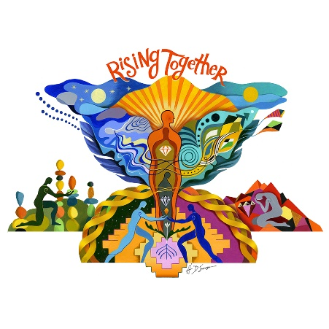by:

Mary Kay Bader

Neurocritical Care Clinical Nurse Specialist

Program:

5:15-5:40 p.m. Networking and Social Gathering

5:40 p.m. AACN-GMAC Welcome and Announcements

5:45 p.m. **Complimentary Dinner Sponsored By: Ceribell/Giveaway**

6:45 p.m. Presentation by Mary Kay Bader

**This is a FREE event. All participants need to RSVP to** [**Milwaukeeaacn@gmail.com**](mailto:Milwaukeeaacn@gmail.com)**.**

Join us at The Alumni Club N88 W16718 Appleton Ave. Menomonee Falls, WI 53051

*Link for evaluation and CE will be provided after the session.*

**Rising Together, We Will Lift Each Other Up!**