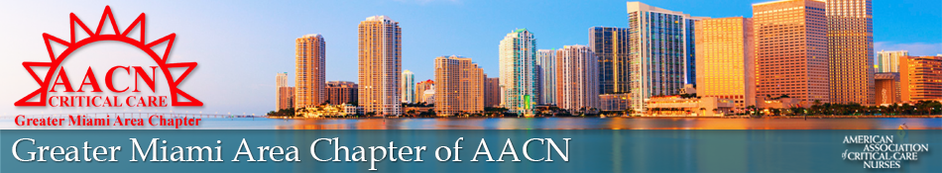

Strategic Meeting Agenda 2022-2023
Welcome = Vianney
Welcome New Officers – Angela, Alex, Shelli, and Glenda
AACN President: Theresa Davis
Chapter Specialist: Mitzi Inman
Region 7 Advisor: Bonnette Webb
GMAC President’s Goal for 2023-2024 (President’s Message).
- Healthy Work Environment/ Guidelines for meeting = Vianney
- Robert Rules on Meetings

- Responsibilities of the Board = Vianney/Yvonne
- Chapter 101-Vianney
- Moderator Access-Yvonne
- Board Position Contract (AACN)-Vianney
- Timely Response to E-mails & Text Messages-Vianney

- Installation of New Officers = Yvonne
- Voting Rights – Vianney
- Board Members (Board of Directors)
- Committee Chair & Co-Chair
- Tie Breakers- Board of Directors
- Liaisons and Members- at-Large- have NO voting rights
- Programs/ Chairs/ Co- Chairs Set-Up = Vianney
- GMAC/AACN Kirkwood Merit Scholarships – Vianney/Angela
- Promotion of Scholarship
- New Excel Spreadsheet for point keeping
- National AACN Scholarship (NTI) – Vianney
- Who is Eligible?
- LDW attendance MANDATORY!
- National AACN Awards to Chapters – Vianney
- Excellence in Chapter Programming
- Excellence in Chapter Collaboration
- Excellence In Leadership Development
- Excellence in Promoting the Value of Certification
- President’s Award for Chapters
- Flyers for Events- Nicole/Shelli
- Dinner Meetings/ Certification and End of Year Luncheon
- Volunteer/Community Service
- Educational Events- CCRN and MTI
- Creating a Contact list of Board Members and Liaisons- Nicole
- QR codes for Education Meetings- Nicole
- Online Check-in for Online meetings and Education- Nicole
- Setting of the Calendar for Board Meetings-Nicole/Shelli(website)
- Setting of the Calendar for Online or in person Educational Meetings-Millie, Nicole/Shelli (website)
- Placing Registration for Educational Meetings-Millie/Linda
- Pricing change for 2023-2024 year for members and non-members
- Refund or no refund
- Setting of the Calendar for Donation/Volunteer Activities-Lynette, Nicole/Shelli (website)
- Places we will volunteer, donate and community teaching
- Management of Pictures in events and GMAC website- Glenda
- Podcast- Vianney
- October, January, April
- Focus on Pediatrics
- Affinity Pay vs Pay pal- Vianney
- Both compatible with Nursing Network
- WhatsApp & Google Drive- Carline, Nicole, & Shelli
- WhatsApp-Carline
- Google Drive (GMAC documents)-Nicole/Shelli
- P.O. Box- Angela
- Online to view mail
- Keys- Yvonne and Vianney
- President to hold Key and one other member
- Storage- Vianney
- Place to maintain all GMAC equipment
- Zelle Payments- Carline
- Payments for Fundraisers
- Budget for 2023 – 2024-Carline/Alex
- Approval of Budget
- Mentorship of future nurses and leaders- Vianney
- Tabling at Universities
- Speaking at Universities
- GMAC mentor for student nurses/ new members
- Workshop for those interested in leadership
- Membership = Yvonne
- Goal for 2023-2024: 50 members (students & nurses)
- Process
- AACN Database
- GMAC Database
Open Discussion


