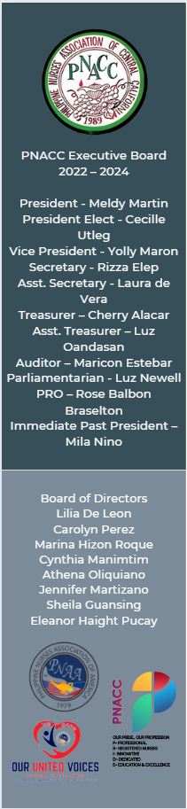

WHAT: 12th International Nursing Conference and 5th Global Summit PNACC Involvement
- Mission 1 : Banate Public Elementary School
6th Grade Book & Laptop Donation
- Mission 2 Medical Mission in Bacolod
- Mission 3: Barangay Bay-ang, Ajuy, Iloilo Feeding Program Program- July-January ($100/month from July-January)

WHERE: Bacolod & Iloilo City, Philippines
WHEN: January 25-27, 2024
PNACC’s giving back to the Philippines for the upcoming 12th International Nursing Conference and 5th Global Summit. $3000 is allocated at this time for these events. Please consider donating for this worthy cause. Contact any PNACC Officers.

All donations are tax-deductible to the extent allowed by law. Philippine Nurses Association is exempt from federal taxes under section 501(c)(3) of the Internal revenue code as a chapter of Philippine nurses Association of America (PNAA).

