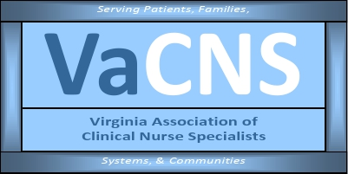

Our Mission:
Promote the role of the clinical nurse specialist as an advanced practice registered nurse in Virginia, and improve systems of care, prevent disease, and enhance health
and well-being through evidence-based care of populations.

MEMBERSHIP MEETING AGENDA

July 10, 2023
5:00 pm to 6:00 pm

Zoom Meeting:
https://us02web.zoom.us/j/611829893?pwd=Tkl1aWJOY0JhelVkMUlUaFpkK0MrZz09

Phone number 1-929-205-6099; Meeting ID: 611 829 893 Passcode: 329587

Discussion Items | Facilitator
Welcome & Announcements  • Introductions  • Member achievements  • NACNS Updates | Erin / Members
Minutes  • Approval of minutes | 2023 minutes updated & will be sent via announcement for member feedback
Reports  • Treasurer  • Social Media  • Standing Committees  - Finance  - Program Planning  - Growth & Succession  - Legislative/Regulatory | Cathy Smith  Amy Lucas  Monica Coles  Donna Bond  Cindy Ward  Sarah Taylor / Becky Bowers-Lanier
Next membership meeting: | August 14, 2023, 5:00 pm

