Fff

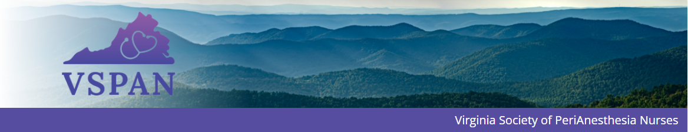

Spring 2023

Volume XXXVIII Issue 1

Inside the Issue:

President’s Address

PANAW

Article: Alpha-gal Syndrome in the Periop Setting

ASPAN National Conference

Abstract: Reducing Opioid Use with the Sound of Music

New Certifications

ABPANC Information

Save the Dates

ASPAN: What is the Component Revitalization SWT?

Government Affairs Update

Editor’s Note

VSPAN Information

Board Members Contact Information

District Contact Information

VITAL TIMES

**President’s Address:**

This year’s ASPAN national conference in Denver, CO was everything I hoped it would be— inspiring and energizing, about connecting with other Perianesthesia nurses, celebrating each other’s accomplishments, and brainstorming how ASPAN should evolve to meet the needs of today’s nurses.

I was impressed that 22 Virginians were present in Denver, representing all 5 of our VSPAN Districts. Many were first time attendees at a national conference. We had a great time meeting each other, comparing notes, and sharing contact information so that we can continue the connections from home. VSPAN was recognized for being an established component for the last 40 years. We celebrated the accomplishments of VSPAN members Lori Servas, Cathy Hayes, and Tiffany Mayhorn, who were presented with a first place Mary Hanna Journalism Award for their article in JoPAN. We had the opportunity to get to know Nikki Price, our new Region 5 Director, and thank Keisha Franks, our outgoing Region 5 Director, for her vital work leading ASPAN’s Component Revitalization Strategic Work Team (SWT).

It was especially rewarding to spend time with members of the other [Region 5](https://www.aspan.org/About/Components/Component-Regional-Boundaries/Region-Five) components. We’ve pledged to forge connections between our components, share resources and events, and support each other. Many of you in Virginia live close enough to attend in-person events held by our neighbors to the north and south, CBSPAN and NCAPAN, and there’s no reason we can’t attend each other’s virtual events. We will also share information that’s relevant across our southeastern region, like the article in this issue about alpha-gal syndrome.

I look forward to more opportunities to connect with you in the year ahead. Mark your calendars for ASPAN’s new Perianesthesia Academy to be held in Albuquerque, New Mexico September 7-9th. VSPAN will be hosting our first in-person conference since 2019 at the Virginia Beach Hilton on Saturday October 7th. And as always, keep up on the latest VSPAN info on our [webpage](https://virginiaspan.nursingnetwork.com/contact) and [Facebook](https://www.facebook.com/vspan2018).

Sincerely,

Amy Ballenger BSN RN CPAN

VSPAN President



**Celebrating PANAW**

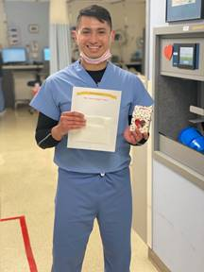 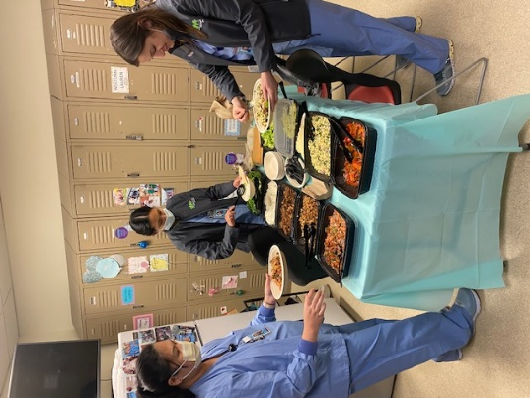

Featuring the PACU at Virginia Hospital Center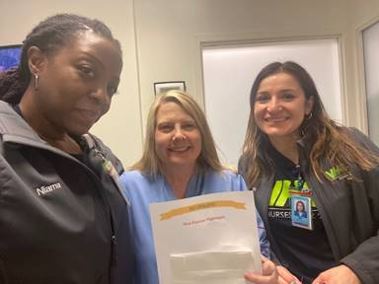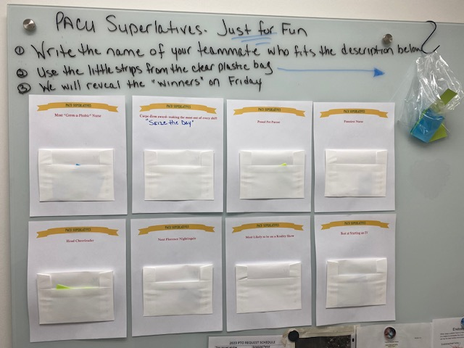

**ARTICLE:**

**Alpha-gal Syndrome in the Periop Setting**

Alpha-gal syndrome, also called alpha-gal allergy or red meat allergy, is a serious potentially life-threatening allergic reaction. Symptoms can occur after exposure to red meat like beef, pork, lamb, or venison, or mammal-derived products like gelatin or milk. Many common medications, from acetaminophen to ondansetron contain mammal-derived ingredients that could trigger an alpha-gal allergic response.

Reactions can range from itching and hives or nausea and diarrhea to angioedema or anaphylaxis. Reactions may be delayed, occurring 2-10 hours after exposure. This delayed allergic reaction can make diagnosis challenging. In addition, not every exposure leads to a clinical reaction, and the presentation is somewhat variable from patient to patient and even from exposure to exposure for the same patient.

Alpha-gal (Galactose-alpha-1,3-galactose) is a carbohydrate molecule carried in the saliva of the lone star tick and the black-legged tick. According to the Annals of Allergy, Asthma and Immunology, there were more than 34,000 documented cases of alpha-gal syndrome in the US between 2010 and 2018, with the highest prevalence in the southeastern United States.

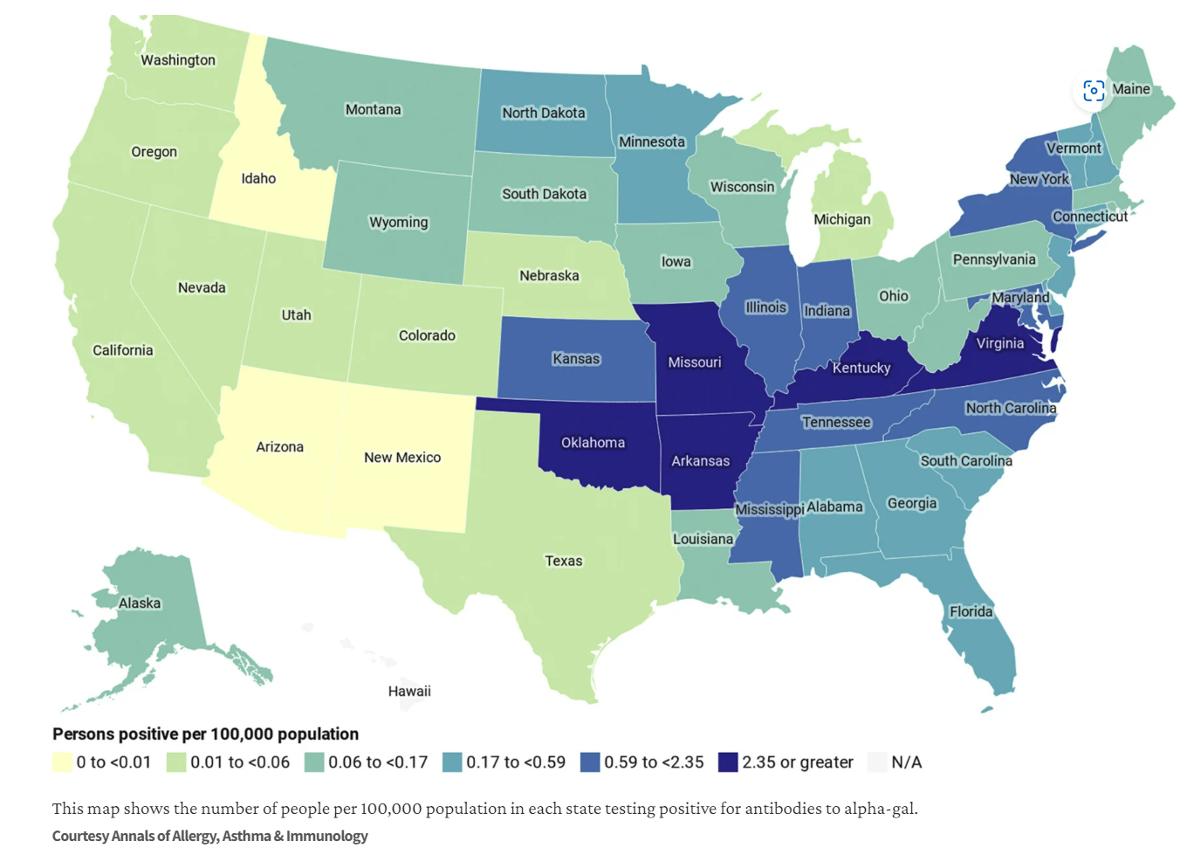

The tick acquires the alpha-gal molecule after feeding on mammalian blood. Alpha-gal is found in most mammals but not in fish, birds, reptiles, or humans. People who are bitten by a tick carrying alpha-gal, especially those who are bitten repeatedly, are at risk of becoming sensitized and producing the IgE necessary to then cause allergic reactions. Serological conversion may take 3-6 months after the tick bite. Subsequent ingestion of mammalian meat or exposure to mammalian products then results in an amplified allergic response. Some individuals’ hypersensitivity may recede with time in the absence of recurrent exposure.

Some medications like heparin are derived directly from porcine or bovine sources. Others have inactive ingredients from mammalian sources that are potential triggers, such as gelatin, glycerol, magnesium stearate, lactose, microcrystalline cellulose, sodium laurel sulfate, and polysorbate. For instance, magnesium stearate and gelatin are found in formulations of acetaminophen, naproxen, lisinopril, clonidine, and hydrocodone, and allergic reactions to these medications have been potentially linked to alpha-gal.2 Many hemostatic products used during surgery are gelatin-based. Identifying all potential triggers is difficult because manufacturers are not currently required to test for or report animal-derived ingredients in their final products. Alpha-gal content may also be subject to change across different lot numbers of the same medication. Manufacturers can freely change information regarding inactive ingredients at any time without warning or follow-up.

If your patient reports that they have “alpha-gal” (they may call it a “red meat allergy”), verify that it’s documented as an allergy in their chart. Make sure all members of the care team are aware of the allergy and the potential for serious reactions to common medications. Don’t administer any medications to the patient without first consulting your facility’s pharmacist. There are numerous online references available identifying specific manufacturers, formulations and lot numbers that are known to contain animal-derived ingredients. But you should always consult your facility’s pharmacist for the most up to date information on the products currently in stock at your hospital or surgery center. Many PO medications with alpha-gal triggering ingredients have IV formulations that are a safe substitute.

Ask your patient about oral medications they have successfully tolerated since acquiring alpha-gal syndrome. Reactions vary widely from person to person. Clinical decisions about which medications to use should be made based off patient tolerability and severity of past alpha-gal reactions.

References:

1. [What Does a Red Meat Allergy Have to Do With Anesthesia? Perioperative Management of Alpha-Gal Syndrome - PubMed (nih.gov)](https://pubmed.ncbi.nlm.nih.gov/29847378/)
2. [A BULL IN A PILL SHOP: ALPHA-GAL ALLERGY COMPLICATING TREATMENT OPTIONS FOR POSTPROCEDURAL HYPOTHYROIDISM - PMC (nih.gov)](https://www.ncbi.nlm.nih.gov/pmc/articles/PMC7282276/#:~:text=For%20instance%2C%20magnesium%20stearate%20and,potentially%20linked%20to%20alpha%2Dgal.)
3. [Diagnostic testing for galactose-alpha-1,3-galactose, United States, 2010 to 2018 - Annals of Allergy, Asthma & Immunology (annallergy.org)](https://www.annallergy.org/article/S1081-1206(20)31274-6/fulltext)
4. [Alpha-gal and Red Meat Allergy (aaaai.org)](https://www.aaaai.org/tools-for-the-public/conditions-library/allergies/alpha-gal-and-red-meat-allergy)
5. [Alpha-gal Syndrome For Healthcare Providers Factsheet | Ticks | CDC](https://www.cdc.gov/ticks/alpha-gal/resources/alpha-gal-syndrome-for-hc-providers-factsheet.html)
6. [What medications are contraindicated with an alpha-gal allergy? What mammal by-products could be listed as inactive ingredients on the package insert (i.e. magnesium stearate, gelatin)? (inpharmd.com)](https://inpharmd.com/inquiries/7b59a192d887a7bce18eb339b9cbc82289c04016bae4cfb8656cbb41a53ce033)

Written by Amy Ballenger BSN, RN, CPAN

**New Education Opportunity:**

ASPAN Perianesthesia Academy

September 7-9th, 2023

Albuquerque, NM

More info to be posted on ASPAN website and Facebook!

**ASPAN National Conference: The Heart and Science of Caring**

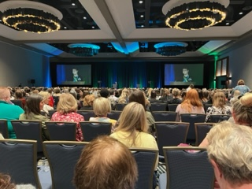

Over 1100 nurses attended ASPAN this year!

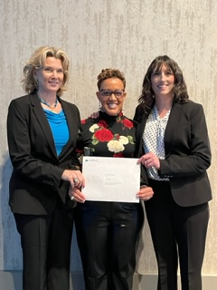

Lori Servas, Cathy Hayes, Tiffany Mayhorn (pictured), and Kerry Milner accepting the 2022 Mary Hanna Award, First Place in "Best Practice" category for their article:

[Navigating the Path to a Sustainable “PACU Pause” and Standardized Perioperative Handoff: A Quality Improvement Project - Journal of PeriAnesthesia Nursing (jopan.org)](https://www.jopan.org/article/S1089-9472(21)00267-7/fulltext)

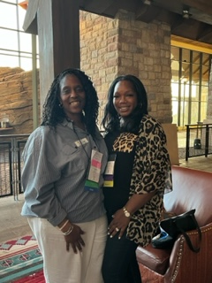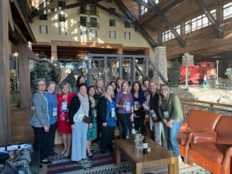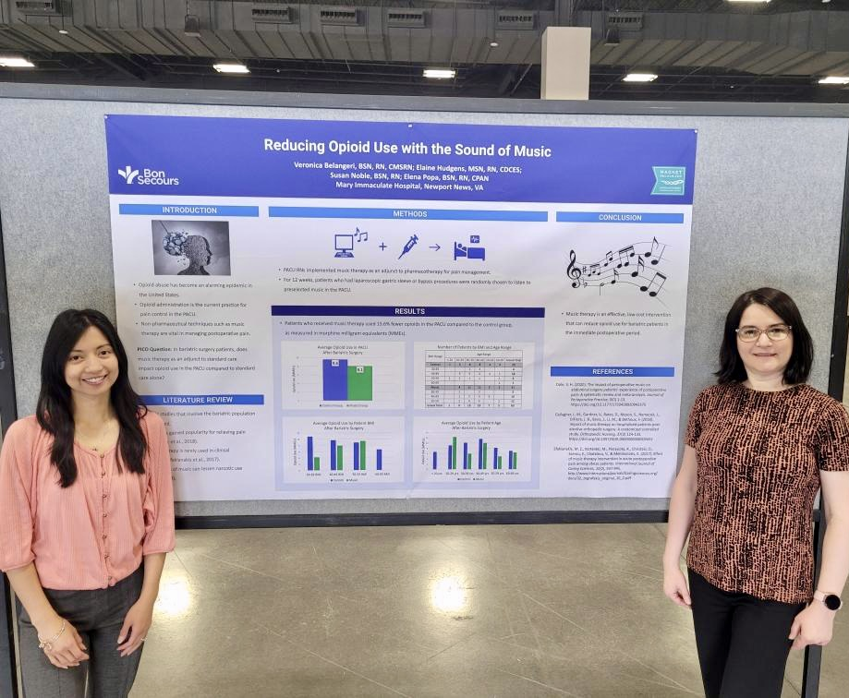

Top left: Keisha Franks and Nikki Price, Region 5’s outgoing and incoming representative.

Top right: Virginia component attendees.

Left: Veronica Belangeri and Elena Popa from Bon Secours presenting their poster Reducing Opioid Use with the Sound of Music.

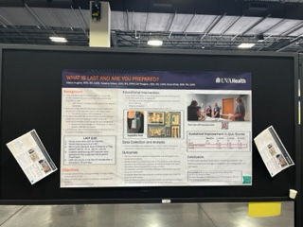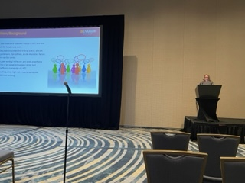

Elaine Hughes from UVA Health presenting poster and oral presentations on What is LAST and are You Prepared?

**Save the Date:**

**2024 ASPAN National Conference in Orlando, FL**

**April 14-18**

**ABSTRACT:**

**Reducing Opioid Use with the Sound of Music**

Primary Investigator: Veronica Belangeri BSN RN CMSRN

Mary Immaculate Hospital, Newport News, Virginia

Co-Investigators: Elaine Hudgens MSN RN CDCES, Susan Noble BSN RN, Elena Popa BSN RN CPAN

Introduction: Many patients experience excruciating pain after bariatric surgery. Opioid administration is the current practice for pain control in the post-anesthesia care unit (PACU). With increasing concerns for opioid misuse, it is imperative to utilize non-pharmacological techniques such as music therapy to manage postoperative pain.

Identification of the problem: Opioid abuse has become an alarming epidemic in the United States. Creative interventions are vital in combatting the crisis at a prevention level. Opioids can also cause significant adverse reactions that can lead to an increased length of stay, delayed postoperative ambulation, and poor patient satisfaction.

EBP Question/Purpose: PICO question. Databases utilized. In bariatric surgery patients, does music therapy as an adjunct to standard care impact opioid use in the PACU compared to standard care alone? Databases utilized were PubMed and Ovid Emcare.

Methods/Evidence: PACU RNs implemented music therapy as an adjunct to pharmacotherapy in managing postoperative pain. Over 12 weeks, patients who had laparoscopic gastric sleeve or bypass procedures were randomly selected to receive music therapy immediately upon arriving in the PACU. Patients in the music group received pre-selected music therapy in addition to standard care. Patients in the control group did not receive music therapy.

Significance of Findings/Outcomes: The data revealed that patients who received music therapy were given 15.6% fewer opioids in the PACU compared to the control group. The data was further analyzed to determine if BMI or age contributed to opioid administration for patients in the music group. On average, patients with a BMI of 49 or less in the music group received fewer opioids than patients in the control group. The data reflected that music had the greatest impact on patients in the 30-39 and 50-59 age groups.

Implications for perianesthesia nurses and future research: Music therapy is an effective, low-cost intervention that can reduce opioid use for bariatric patients in the immediate postoperative period. The project team desires to explore the impact of music therapy on other surgical populations and to expand its use in all phases of acute care

**CAPA/CPAN New Certifications:**



**CAPA:**  
Tanya Bevins

Jenna Tomajko

Brenda Boccolucci

Brianne Blankenberger

Haregewein Sirak

Michelle Merk

Janice Mellette

**CPAN:**

Ella Rakitin

Nancy Taylor

Rebecca Richmond

Rebecca Nelson

Anne Gerosimo

Samantha Frank

Amy Braun

**Do You Have a Question About Patient Safety or Best Practice?**



Contact the Clinical Practice Committee at ASPAN via email and they will confidentially respond to your inquiry.

Check the FAQ page for information at [Clinical Practice FAQs (aspan.org)](https://www.aspan.org/Clinical-Practice/Clinical-Practice-Frequently-Asked-Questions)

**ABPANC Info:**

Need help to get ready for the CAPA or CPAN exam? Contact one of the volunteer ABPANC Certification Coaches in Virginia:

Laurie Waldron [lashton31@yahoo.com](mailto:lashton31@yahoo.com)

Alicia White [alicia3kids52@yahoo.com](mailto:alicia3kids52@yahoo.com)

Rebecca Gilbert rg4w@uvahealth.org or [nursecivility@gmail.com](mailto:nursecivility@gmail.com)

Amy Ballenger alb3w@uvaheath.org

Donna Goyer dmgoyer@gmail.com

Katie Scully [kathryn.scully@inova.org](mailto:kathryn.scully@inova.org)

[Contact ABPANC - American Board of Perianesthesia Nursing Certification, Inc. (cpancapa.org)](https://www.cpancapa.org/about/contact-us/)

SAVE THE DATE!!!



CAPA/CPAN Fall Exam Registration

July 1-October 31

Exam Administration Window

September 15 -November 15

[Nursing Certification Schedule and Fees - CPAN® and CAPA® Certification (cpancapa.org)](https://www.cpancapa.org/become-certified/schedule-fees/)

**VSPAN Fall Conference**

**October 7th, 2023**

**Virginia Beach @ the Hilton**

**ASPAN: What is the Component Revitalization SWT?**

The Component Revitalization Strategic Work Team (CRSWT) was developed during Jennifer Kilgore’s ASPAN Presidency. The purpose was to enhance leadership qualities of component leaders with the focus to continue the development and prosperity of the structure and function of their component operations within the framework of ASPAN. I know that is a mouthful so in a shorter version, the purpose is that ASPAN leadership in collaboration with the CRSWT will provide support to component leadership. In 2022, I was appointed as the coordinator for the CRSWT. Myself and the members of the CRSWT realized that we had more members than leaders. How do you support or revitalize non-existent leaders? The status of ASPAN was there were 19 of 40 components that had either no leadership or were functioning with a board of 2-3 members. In collaboration with the ASPAN Board of Directors, the ASPAN National Office and the CRSWT, a survey was developed to hear the voice of the membership regarding their view of components. The ASPAN Board of Directors agreed to share these results with the 2023 Representative Assembly (RA) as these distinguished members will be the voice for the ASPAN membership for 2023-2024. Any items/issues warranting a vote disseminating from the CRSWT will be voted on by these designees. They will also be expected to share the information with their components prior to casting their votes.

Most of the members of the RA were astonished by the question … “Would you be willing to consider serving on your component’s board?” The overwhelming answer was no (70.09%). This question elicited much conversation at the President’s Luncheon and carried on into the executive session at RA. As the continuing coordinator for the CRSWT, I have shared the additional input received through the provided QR code and the luncheon. I want you all to be encouraged that the future of ASPAN and its components are not a lost cause. I was revitalized by the energy and multiple conversations had with the new members of ASPAN. Their ideas were innovative and intuitive. They appreciate and understand the importance of components. They value the benefits and collegiality. We can start a huge fire with a little spark!!!! I believe the awareness of the current state of our components has ignited that spark. The 2023 CRSWT members have been assigned by ASPAN President Alphonzo Baker, Sr., DNP, MSN, RN, CAPA. I have sent out the first email with all of the information for our first meeting. I am looking forward to a busy but rewarding year!!!!

“Learning and innovation go hand in hand. The arrogance of success is to think that what you did yesterday will be sufficient for tomorrow”- William Pollard

Keisha Franks, MSN, RN, CPAN

2023 ASPAN Component Revitalization SWT Coordinator

**Spring Government Affairs Update:**

As the 118th Congress gets underway, the primary areas of focus for nursing continue to be those shared during previous Congress sessions. These include:

Improving Care and Access to Nurses (ICAN) Act, Workplace Violence Prevention Legislation and encouraging congress to make the waivers provided under the Public Health Emergency (PHE) permanent.

The Nursing Community Coalition has sent letters to congress in support of this legislation. Additionally, they have provided testimony and requests for information in support of funding for Title VII Nursing Workforce Development Programs. The amount requested is at least $530 million for development programs and at least $210 million for the National Institute of Nursing Research for the proposed FY 2024 budget.

In Virginia, the General Assembly ended their scheduled session in March, with no final budget to submit to the Governor. An April special session will be convened to finalize this as well as address any amendments to proposed legislation by the governor.

There were some legislative successes from this session which include:

Funding for the APRN Virginia Preceptor Incentive Program and nursing scholarship programs at the Virginia Department of Health. The State Loan Repayment Program for healthcare workers was also approved for funding. Tuition assistance grants for graduate students seeking degrees in healthcare were increased. A study by the State Council of Higher Education was established to review needs and barriers to nursing education to help address nursing shortages.

From ASPAN, we can expect to see increased education and legislative engagement regarding Healthy Workplace Environments (HWE). As members you have likely seen several messages from President Connie Hardy-Tabet regarding this. There is a new HWE section on the ASPAN website, under publications and resources. You can access this without being logged in as a member. The two initial topics are Civility and Waste Anesthesia Gases (WAGs). On the website you will find White Papers, position statements and safety alerts related to these topics. You will also find a series of HWE and other advocacy videos with free CE’s for members on ASPAN Learn. I encourage you to check out this website and take advantage of free contact hours and increase your advocacy engagement!

Feel free to contact me with questions or suggestions. I welcome you to share any advocacy or legislative activities you may engage in, possibly for inclusion in future Vital Times issues.

Respectfully,

Donna Goyer BS, RN, CPAN, CAPA

VSPAN GA Chair

ASPAN GA SWT Coordinator 2022-2023

[dmgoyer56@gmail.com](mailto:dmgoyer56@gmail.com)

Resources

[www.thenursingcommunity.org](http://www.thenursingcommunity.org)

[www.rnaction.org](http://www.rnaction.org)

[www.virignianurses.com](http://www.virignianurses.com)

[www.aspan.org](http://www.aspan.org)

**Editor’s Note:**

Hello everyone. Thank you for reading Vital Times. I hope you found it valuable to your work. Please send me any projects you are working on in your units. I would love to show everyone the great, meaningful work we do as perianesthesia nurses. If there is a certain topic that you would like to see please reach out to me. Also please send as many pictures as you can so that we can see the work you are doing!

Take care,

Elaine Hughes BSN, RN, CAPA

Emo2j@uvahealth.org

**VSPAN Mission:**

VSPAN will be recognized in Virginia as a leading association and resource for Perianesthesia Nursing education and practice.

**VSPAN Goals:**

VSPAN will align and function with ASPAN’s Core Values.

**CARES**-**C**ourage. **A**dvocacy. **R**espect. **E**xcellence. **S**ervice.

VSPAN Mailing Address

VSPAN

**C/o Leanne Davis**

**PO Box 371**

**Louisa, VA 23093**

Articles/Pictures/Submissions for Vital Times:

Elaine Hughes- [emo2j@uvahealth.org](mailto:emo2j@uvahealth.org)

VSPAN Website: Virginiaspan.nursingnetwork.com

**VSPAN Board of Directors Contact Information:**

**President**  
*Amy Ballenger, BSN, RN, CPAN – alb3w@uvahealth.org*

**Vice President/ President-Elect**  
*Vacant*

**Immediate Past President**

*Pam Champigny, MSN, RN -pamelachampigny@yahoo.com*

**Secretary**  
Melanie Prince, BSN, RN, CCRN-bloughm@comcast.net

**Treasurer**

Leanne Davis, MSN, RN, CPAN – lnc6t@uvahealth.org

**Membership Chair**  
Alicia White, BSN, RN, CAPA – arw9v@uvahealth.org

**Publications (Newsletter Editor) Chair***Elaine Hughes, BSN, RN, CAPA – emo2j@uvahealth.org*

**Education Chair**  
[*Carolyn Tucker, BSN*](mailto:cwtucker@sentara.com)*, RN- cwtucker@sentara.com*

**State Conference Co-chair**

[*Carolyn Tucker, BSN*](mailto:cwtucker@sentara.com)*, RN- cwtucker@sentara.com*

**By-Laws/Policies & Procedures Chair**  
Amy Ballenger, BSN, RN, CPAN

**Public Relations/Marketing Chair**  
Leanne Davis, MSN, RN, CPAN

**Government Affairs Chair**   
[*Donna Goyer, BS, RN, CPAN, CAPA*](mailto:dmgoyer@carilionclinic.org)*- dmgoyer56@gmail.com*

**Ways & Means Chair**  
*Vacant*

**Historian**  
vacant

**VSPAN District Contacts:**

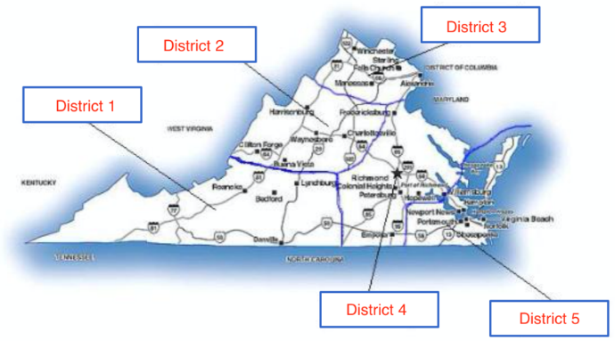

**District 1 - Southwestern Virginia**  
Roanoke/Lynchburg/Danville/Bristol  
Lori Servas, BSN, RN IV, CPAN  
*Loribell216@aol.com*

*&*

Tiffany Mayhorn, MSN, RN *tgmayhorn@gmail*.com

**District 2 - Northwestern Virginia**  
Harrisonburg/Waynesboro/CharlottesvilleAmy Ballenger BSN RN CPAN *ALB3W@uvahealth.org*

**District 3 - Northern Virginia**  
Winchester/Sterling/Falls Church/Manassas/Alexandria  
*Katie Scully- Kathryn.scully@inova.org*

**District 4 - Central/Northeastern Virginia**  
Richmond/Petersburg/Emporia  
Pam Champigny, MSN, RN  
[*pamelachampigny@yahoo.com*](mailto:pamelachampigny@yahoo.com)

**District 5 - Southeastern Virginia**  
Williamsburg/Chesapeake Bay/Virginia Beach/Norfolk/Newport News  
Carolyn Tucker, BSN, RN  
*cwtucker@sentara.com*