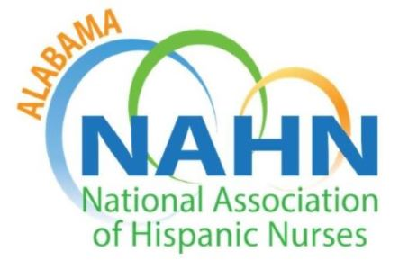

AL NAHN Chapter Meeting Minutes
Thursday, March 30, 2023; 6:00 pm

Members Present

Grace Grau Sonia Turner Jonny Pena Martinez
Gaby Romero Jessica Hernandez Carlos Guerrero
Carlos Martinez Diaz

Members Absent
Felesha Bowen Cinthia Gonzalez Maria Shirey
Norma Cuellar Natalia Lopez Leslie Santiago
Maria Flanigan Ashley Morales Frank Puga
Christine Gil Francisco Negron

Meeting was called to order by Grace Grau, Interim President/Treasurer AL-NAHN at 6:00 pm

APPROVAL OF MINUTES
Motion made by: A quorum was not present

REPORTS:
- Treasurer report: $30,844.50
Recurring Monthly Expense: $32.40 per month for storage unit (Price increased from
$27.90/mo)

OLD BUSINESS
- Health Screening at LaVida Barberia
  - Volunteer opportunity for members. Three community clinics completed in April, May, and August 2022.

- Scholarships: Applications for chapter Scholarships will be available from May 1-31. Applicants must be an active member of the chapter. Members can also apply to national scholarships. Scholarships available for non-nursing/ affiliate members. Applications will be accessible through NAHN AL website.

NEW BUSINESS- Presented by Dr. Grau
There are several upcoming professional and volunteer events-
- Nurses Day at the Capital
  - Wednesday, April 5, 2023, Montgomery, AL
  - Open to all members. Gathering of nurses. Networking opportunity. Please request off from work so that you can attend. If members want to go contact Dr. Grau (205) 753-1586 or email nursegg@uab.edu.

- Booker T. Washington Health Club
  - Friday, May 12, 2023, 9:00 am to 2:15 pm at the UAB SON
  - Volunteer opportunity open to all members. 7-8th graders interested in a nursing or health professions career.

- Hispanic Festival on June 10, 2023, in Greenville, AL.
- Fiesta Birmingham in September 2023 in Birmingham, AL.

- National Conference
  - July 11-14, 2023, Portland, Oregon
  - Latino Leadership Institute (LLI) on July 11, 2023. Professional workshop prior to national conference.
  - New bylaw change proposed to National by Dr. Grau for new member category that would allow 18 y/o high school students to join NAHN. Voting will occur this summer.

- Student Support Group
  - Open to all students across all levels. Monthly meeting at UAB SON only for student members. The second Thursday of every month from 3-4 pm at UAB SON.

OTHER/ANNOUNCEMENTS

- Next meeting will be on Thursday, April 27, 2023. Chapter meetings will be held at UAB School of Nursing (SON) on the last Thursday of every month at 6:00 pm with on site and remote attendance capabilities.
SON address: 1701 University Blvd Birmingham Nightingale Room (1071)

Meeting adjourned at 7:00 pm
Motion made by Grace Grau to adjourn meeting second by Carlos Martinez Diaz.

