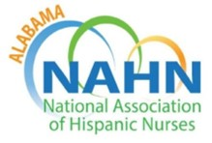

AGENDA
NAHN Alabama
Meeting April 27, 2023-6:00-7:00 p.m. CST
Zoom: https://uab.zoom.us/j/8374826905
Or by phone: +16468769923, Meeting ID: 837 482 6905

MEETING PURPOSE & GOALS
- Action on Routine Matters through consent agenda
- Discussion and action on strategies, initiatives
- Updates from leaders on key
_____________________________________________________________________________________
I. Call to Order
II. Consent Agenda
- Board Meeting Minutes of March 2023
- Treasurer report
III. President Update
- ALNAHN
- NATIONAL
- National Board Elections are coming up on June 1 (Look over slate of candidates)
- Serve on National Committee

- National Conference plans (July 11-15) Portland Oregon
IV. Items for discussion and action
V. Round Table
Adjourn

