
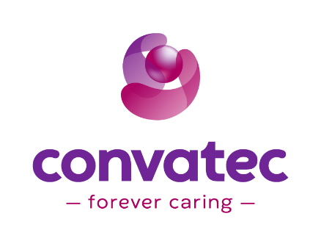
Tuesday

You are invited to:

To Conquer or Be Defeated: The Strategy Behind Winning the Wound Infection Battle

Tuesday June 6th – 5:30pm

Andiamo
38703 7 Mile Rd
Livonia, MI 48152

Speaker:
Estelle Zanotti, MSN, RN, CRRN, CWON
Clinical Solutions Specialist

RSVP by May 23rd:
greaterdetroitaacn@gmail.com
Liz Eggly (586)742-1621 Elizabeth.Eggly@convatec.com


Hosted by:
Greater Detroit Chapter AACN
Convatec Advanced Wound Care

By accepting the meal and/or refreshments offered with this program, you represent that neither the state(s) in which you are licensed nor your employer(s) prevent you from accepting these items. In adherence with AdvaMed guidelines, medical education programs are for healthcare professionals only and inclusion of a healthcare professional’s spouse or guest is prohibited.
US Physicians Only: All “per attendee” costs, related to this educational meal event, will be reported by name, as per the Federal Sunshine-CMS Open Payments disclosure requirements. If you prefer to “opt out” and decline the meal associated with this event, you must indicate this in your RSVP email to the Convatec organizer.
Vermont Licensed Healthcare Professionals: HCPs licensed in this state, are not eligible to participate in this educational meal event.
Massachusetts Licensed Healthcare Professionals: All “per attendee” costs, related to this educational meal event, will be reported by name, as per MA transparency and disclosure requirements.
Connecticut Licensed APRNs: All “per attendee” costs, related to this educational meal event, will be reported by name as per CT transparency and disclosure requirements.

