Get your tickets now!
Maryland Nurses Association District 9’s raffle
With prizes valued at $500, this package has a lot to offer!
Chances are $10/ticket
Winner will be announced on May 23rd
at the Annual District 9 Spring Dinner and Awards Celebration
To buy your tickets, scan the QR code below or use the link: https://square.link/u/U0jRIlFE

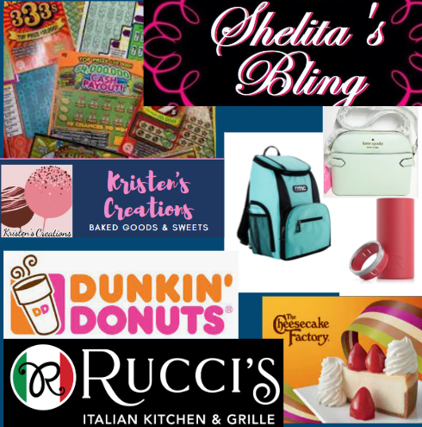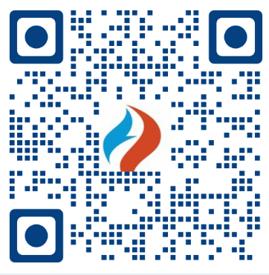

Prize Package Includes:
RTIC Lightweight 15 Can Backpack Cooler in Aqua and Black
Two RTIC 12oz Skinny Can Cooler in Pacific Glitter and Brick Matte
Kate Spade Staci Dome Crossbody in Crystal Blue
$100 Bobby Rucci’s Gift Card
$100 Scratch Offs
$50 Cheesecake Factory Gift Card
$40 Paparazzi Shelita’s Bling Gift Card
$25 Dunkin Donut Gift Card
$25 Kristen’s Creations
Bottle of Red Wine

