MESPAN Board of Directors Candidate Bio:
Position of Board Member at Large
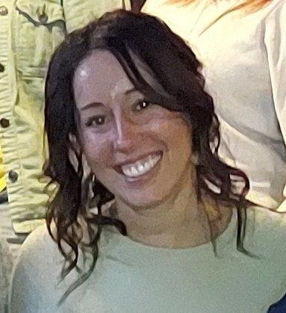 Brandy Boissoneault RN MSN

- Name, credentials, clinical ladder
Brandy Rae Boissoneault, RN MSN
- Place of employment, type of unit, title
Northern Light Mercy Hospital, ACU/PACU, Clinical Nurse Lead
- Number of years in current position, prior nursing experience
Northern Light Mercy Hospital ACU/PACU, 2011 – Present
Coastal Women’s Healthcare, 2006-2011
Northern Light Mercy Hospital, Medical Surgical Unit, 2003-2009
- Committees, projects, responsibilities, other contributions
Committees: Vascular Access, Pressure Injury Prevention, Cerner Superuser (electronic health record), Professional Development (chair 2020- present), Disease Specific (total joint and spine certification), Professional Advancement, Patient Experience Team, Recruitment and Retention
Projects: Total joint arthroplasty same day discharge program
Responsibilities: responsibilities include working closely with the manager and other stakeholders to maintain clinical practice, staff education and orientation, development of quality initiatives, adherence to policies, producing the unit schedule, overseeing, and coordinating unit-based projects produced by staff, management of daily conflicts, and patient and staff advocate. Ultimately, I assist with/support the team to ensure the delivery of quality patient care.
- Awards received
Sister Mary Consuela White Nursing Excellence Award
- Current professional associations
MESPAN, ASPAN
- Nursing related, civic, religious, or other volunteer activities
- Personal/family information
I live in Saco with my family, husband, son, and daughter. I enjoy traveling, snowboarding, paddleboarding, being outdoors, and being surrounded by friends and family.
- I am interested in joining the MESPAN board of directors because:
By joining the MESPAN board of directors I hope to gain and provide professional support and knowledge to improve care provided and create a thriving perianesthesia workforce. Joining MESPAN supports this through networking with a community specific to perianesthesia nursing, staying current, and being an active participant.
- If I am elected to the MESPAN Board of Directors, the talents and gifts I offer are:
If I am elected to the MESPAN board of Directors, I will bring my passion for quality patient care, evidence-based practice, a just culture, and the importance of lifelong learning. I enjoy developing education, project management, empowering and engaging others, and fostering and positive patient experience. I am always looking for innovative ways to improve and grow both professionally and personally.

