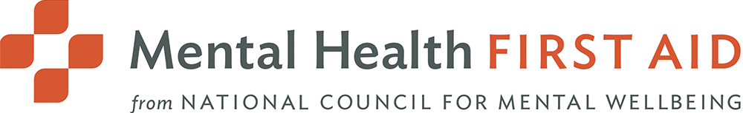  Mental HEalth first aid training for Clinical & nursing staff  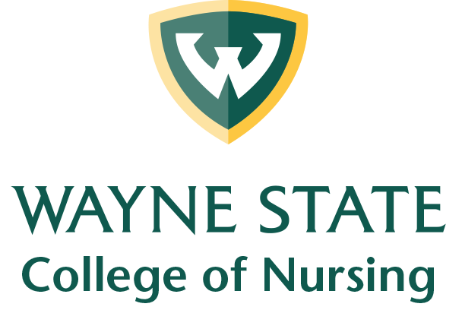  A Quality Improvement Project by:  Sarah Pepperday, BSN RN  DNP Student at Wayne State University  Do you know how to identify signs of worsening mental health in adults? Would you know how to respond and provide support if someone was experiencing a mental health crisis?  Mental Health First Aid Training (MHFA) is an interactive and engaging training session designed to help participants learn how to recognize signs and symptoms of mental health challenges in adults and how to help in a mental health crisis.  This course is valued at $170 but is FREE thanks to funding from the Health Resources and Services Administration (HRSA).  *This project is supported by the HRSA of the U.S. Department of Health and Human Services (HHS) under grant number UB6HP31690. | Please participate in the survey QR code link regarding training options!    This is a DNP Quality Improvement Project designed to increase access to MHFA.  Please contact Sarah for more details at:  Email: Fh9465@wayne.edu  Cell: 814-592-6569

