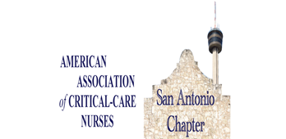  Chapter Meeting  May 18, 2023  6:00-8:30 pm  RSVP Required:  https://sachapteraacn.nursingnetwork.com/  http://www.facebook.com/SAchapterAACN/  or scan the QR code below  SAN ANTONIO CHAPTER AACN  Live Dinner Meeting and Education Event  Location:  Pappasito’s  10501 I-10, San Antonio, TX 78230  Dinner Provided  (Non-member donation- $10.00 – support scholarships to conference)   | Schedule  6:00-6:15p registration  6:15-7:15  Welcome  The Guardian System  By Turn Care  7:15-8:15 pm  Chapter mtg  8:15-8:30 pm  Closing Comments Adjourn  Register:  sachapteraacn.  Nursingnetwork.com  Dinner Sponsor:  Turn Care

