**Better Safe Than Sorry – Contemporary Topics in Medication Safety**

**Casey Wilbert, PharmD, MBA, BCPS, Senior Director of Acute Care Pharmacy Services at Rochester Regional Health**

**and Hannah Fifield, Pharm D, PGY1 Pharmacy Resident**

Sponsored by NACNS-WNY chapter

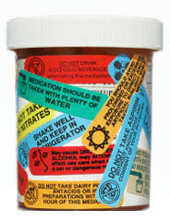

Join us for our virtual meeting!

Thursday, May 4th

Via Zoom, Link upon RSVP

RSVP with email address to Eileen Wilbert: [ewilbert@sjf.edu](mailto:ewilbert@sjf.edu) by May 1st.

Members of NACNS-WNY, free

Non-members $5.

Please send check made out to NACNS-WNY to 5211 County Line Road Webster, NY 14580

5pm-6pm: Presentation

6 pm-6:15 pm: Business meeting for members only

1 ceu pending approval