 | 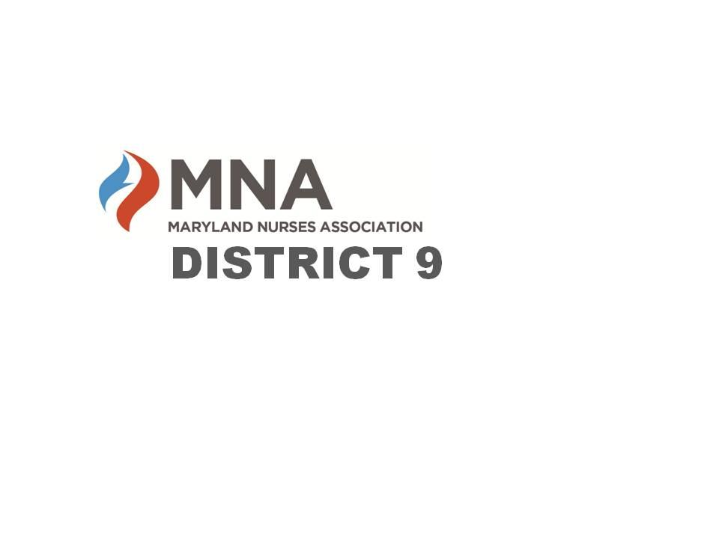
2023 Annual MNA District 9 Nursing Awards

The Maryland Nurses Association District 9 is seeking nominations for their 2022 Nursing Awards. Candidates must be a resident, employee, or student in District 9 (Calvert, Charles, and St. Mary’s Counties) and may only be considered for one award.
Deadline: Applications must be submitted in their entirety no later than Friday May 5th. Awards will be presented at the MNA District 9 Annual Awards Dinner on Tuesday May 23, 2023, at the CSM Hughesville Regional Campus. Attendance is encouraged. For more information, visit our website or Facebook page (see below).

- The Nurse Educator Award is presented to an outstanding Registered Nurse whose primary focus is education. Nominees for this award may include nurses teaching in areas of staff development, community-based education, and schools of nursing.
- The Paula Luskus Heart of Service Award recognizes a Registered Nurse who is an outstanding member of our profession. Paula Luskus was well known as an inspirational leader who demonstrated a deep passion and dedication to the nursing profession. She was a strong advocate in the promotion of nursing and mentored many. Paula cared deeply for everyone she knew, and her generosity shined throughout her community. The recipient of this award must be well rounded, demonstrating perseverance and passion in the field of nursing and the community.
- The Nurse of the Year Award gives public recognition to an individual who demonstrates excellence in nursing. Licensed, practicing Registered Nurses in all fields of nursing are eligible.

Nursing Scholarships and Nursing Student of the Year Award will also be presented.
Contact us for more information or visit our website or Facebook page.
https://www.facebook.com/MNADistrict9 or https://mnadistrict9.nursingnetwork.com/

District 9 Nurse Educator Award

The District 9 Nurse Educator Award is presented to an outstanding nurse whose primary focus is education. Nominees for this award may include nurses teaching in areas of staff development, community-based education, and schools of nursing.

Candidate’s Name _________________________________________________
Address __________________________________________________________
Phone __________________ Email ____________________________________
Place of employment ___________________________________________________
Job title ______________________________________________________________
Area of practice________________________________________________________
Number of years’ experience in nursing _______

Letter of Recommendation:
Describe your association with the candidate and how as a nurse educator they have made a positive impact on a patient, family, colleague, or community. This may be through practice, community service, professional development activities, publications, continuing education, teaching, presentations, etc. For blind selection purposes, please do not name the nominee in your letter of recommendation, only on this nomination form.

Your Name_____________________________Date_______________
Place of Employment__________________________ Job Title_________________
Email Address ____________________________Phone______________________

Paula Luskus Heart of Service Award

The Paula Luskus Heart of Service Award recognizes a Registered Nurse who is an outstanding member of our profession. Paula Luskus was well known as an inspirational leader who demonstrated a deep passion and dedication to the nursing profession. Paula was a member of the District 9 Board for many years making tremendous contributions to the organization. She was a strong advocate in the promotion of nursing and mentored many. Paula cared deeply for everyone she knew, and her generosity shined throughout her community. The recipient of this award must be well rounded, demonstrating perseverance and passion in the field of nursing and the community.

Name of Candidate________________________________________________
Address __________________________________________________________
Phone __________________ Email ____________________________________
Place of employment _____________________________________________
Job title__________________________________________________________
Area of practice_______________________________________________________
Number of years’ experience in nursing _______

Letter of Recommendation:
Describe your association with the candidate and how the nurse’s direct nursing care and professionalism have made a positive impact on a patient, family, colleague, or community. This may be through practice, community service, professional development activities, publications, continuing education, teaching, presentations, etc. For blind selection purposes, please do not name the nominee in your letter of recommendation, only on this nomination form.

Your Name _____________________________Date_______________
Place of Employment__________________________ Job Title_________________
Email Address ____________________________Phone______________________

District 9 Nurse of the Year

The District 9 Nurse of the Year Award gives public recognition to an individual who demonstrates excellence in nursing. Licensed, practicing Registered Nurses in all fields of nursing are eligible.

Name of Candidate ________________________________________________
Address __________________________________________________________
Phone __________________ Email ____________________________________
Place of employment __________________________________________________
Job title _____________________________________________________________
Area of practice_______________________________________________________
Number of years’ experience in nursing _______

Letter of Recommendation:
Describe your association with the candidate and how the nurse’s direct nursing care and professionalism have made a positive impact on a patient, family, colleague, or community. This may be through practice, community service, professional development activities, publications, continuing education, teaching, presentations, etc. For blind selection purposes, please do not name the nominee in your letter of recommendation, only on this nomination form.

Your Name _____________________________Date_______________
Place of Employment__________________________ Job Title_________________
Email Address ____________________________Phone______________________

