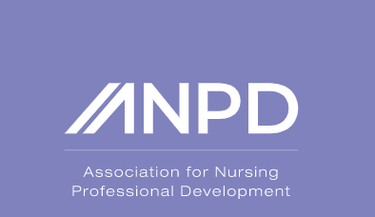
ANPD Affiliate of Central Florida is hosting its first quarterly member meeting!
Guest Speaker:
Mary G. Harper, PhD, RN, NPDA-BC
When: March 23, 2023 6:00 pm to 8:00 pm
Where: AdventHealth Fish Memorial Waves Conference Center/Beach Conference Room (Virtual option available)
Who may attend: ANPD Affiliate of Central Florida members, members may bring a friend.

Annual Membership: $30.00
Future meetings will be $5 per meeting for non-members
Great opportunity for networking!

