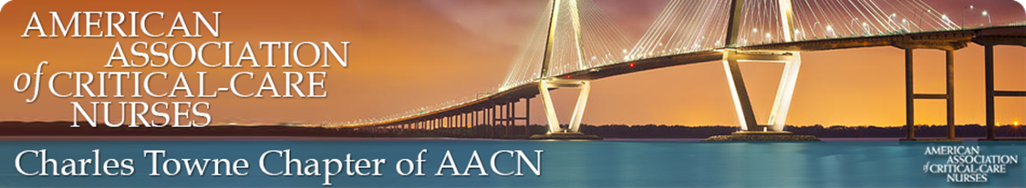

**2023 NTI SCHOLARSHIP FOR CHAPTER MEMBERS**

Our service for this quarter is to invest into our members! We are offering a NTI scholarship to two of our members for this upcoming NTI in Philadelphia, PA May 22nd-24th In Person **OR** June 12-14th Virtual.

The scholarships will be for the early bird member registration for the FULL conference for choice of in person or virtual. **DEADLINE FOR EARY BIRD** **REGISTRATION IS APRIL 10th.** The recipients will be responsible for all other expenses (travel, hotel, food, etc). The recipients will be reimbursed **AFTER** the conference and upon the provision of the confirmation of attendance receipt from AACN.

If you are interested, the scholarship application is attached and should be submitted no later than **April 3rd to**[**grace.rankin@rsfh.com**](mailto:RHRGET@HOTMAIL.COM)**OR 843-568-9474 ( scan or email/text a pic of completed document is acceptable).**You do not have to complete the meeting attendance section as this will be reviewed from our documented attendance. For more information about NTI, visit AACN.org, select conferences & events to be directed to NTI.

