
Presents a FREE virtual event:
SURROGATE MEDICAL DECISION MAKING
with
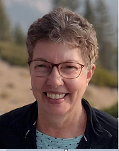
Barbara Opperwall ACHPN, ACNS-BC, NP
Tuesday February 21, 2023
Membership Meeting: 6:30 PM -7:00 PM
Presentation begins: 7:00 PM- 8:30 PM
This presentation will cover essential issues health care providers need to consider when assisting patients and families with advance care planning and surrogate medical decision making including important legal concepts.
1.5 Nursing CEU’s (from GVSU Kirkhof College of Nursing) for registered attendees who enter full name and email address into meeting Zoom chat, attend the entire event, and complete the evaluation to be eligible for CEU (after completion of the event, a link to the evaluation will be provided to registered participants, from which the CEU certificate can be downloaded and printed).
TO REGISTER FOR THIS EVENT Please CLICK THE LINK BELOW
https://wmhpna.nursingnetwork.com/nursing-events/139751-surrogate-medical-decision-making#!info
ONLY REGISTERED PARTICIPANTS WILL BE ELIGIBLE TO RECEIVE NURSING CEUs

