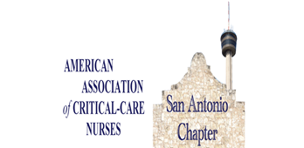  Fundamentals of nasal high flow (NHF) therapy  1.0 Hr cerp accrediated by aacn  february 16th, 2023  6:00-8:00 pm  Dinner and Education  Perry’s Steakhouse & Grille  15900 La Cantera Pkwy, Unit 22200  San Antonio, TX 78256  Scan to register on Nursing Network  Free to SAAACN members   | Schedule  6:00-6:30 Registration/ Networking  6:30-7:00 pm  Chapter Meeting  7:00-8:00 pm  Presentation by Amber Haikenwaelder  Register:  sachapteraacn.  nursingnetwork.com  Dinner sponsored by:  

