Greater Detroit AACN Educational Guest Lecture

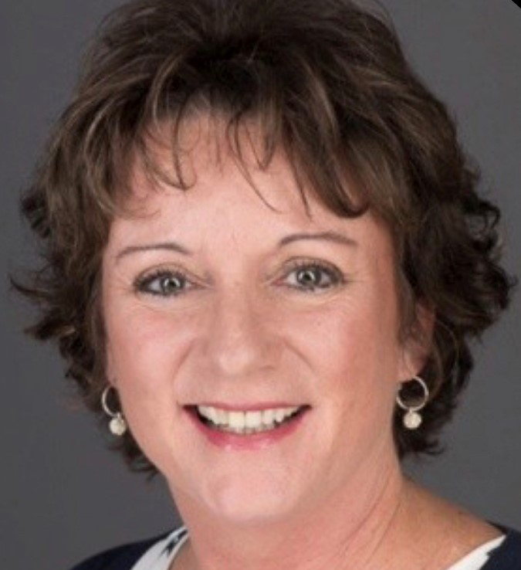

OPTIMIZING

FECAL CONTAINMENT

With ConvaTec

March 28, 2023
Sign in: 5:30-6pm / Speaker & Dinner: 6:00pm

Location: Seasons 52
1000 W. Big Beaver Road
Troy, MI 48084

Meet the Speaker:
Kim Sisson
MSN, CCRN,CPXP
Clinical Specialist, Critical Care


RSVP by March 24
greaterdetroitaacn@gmail.com

