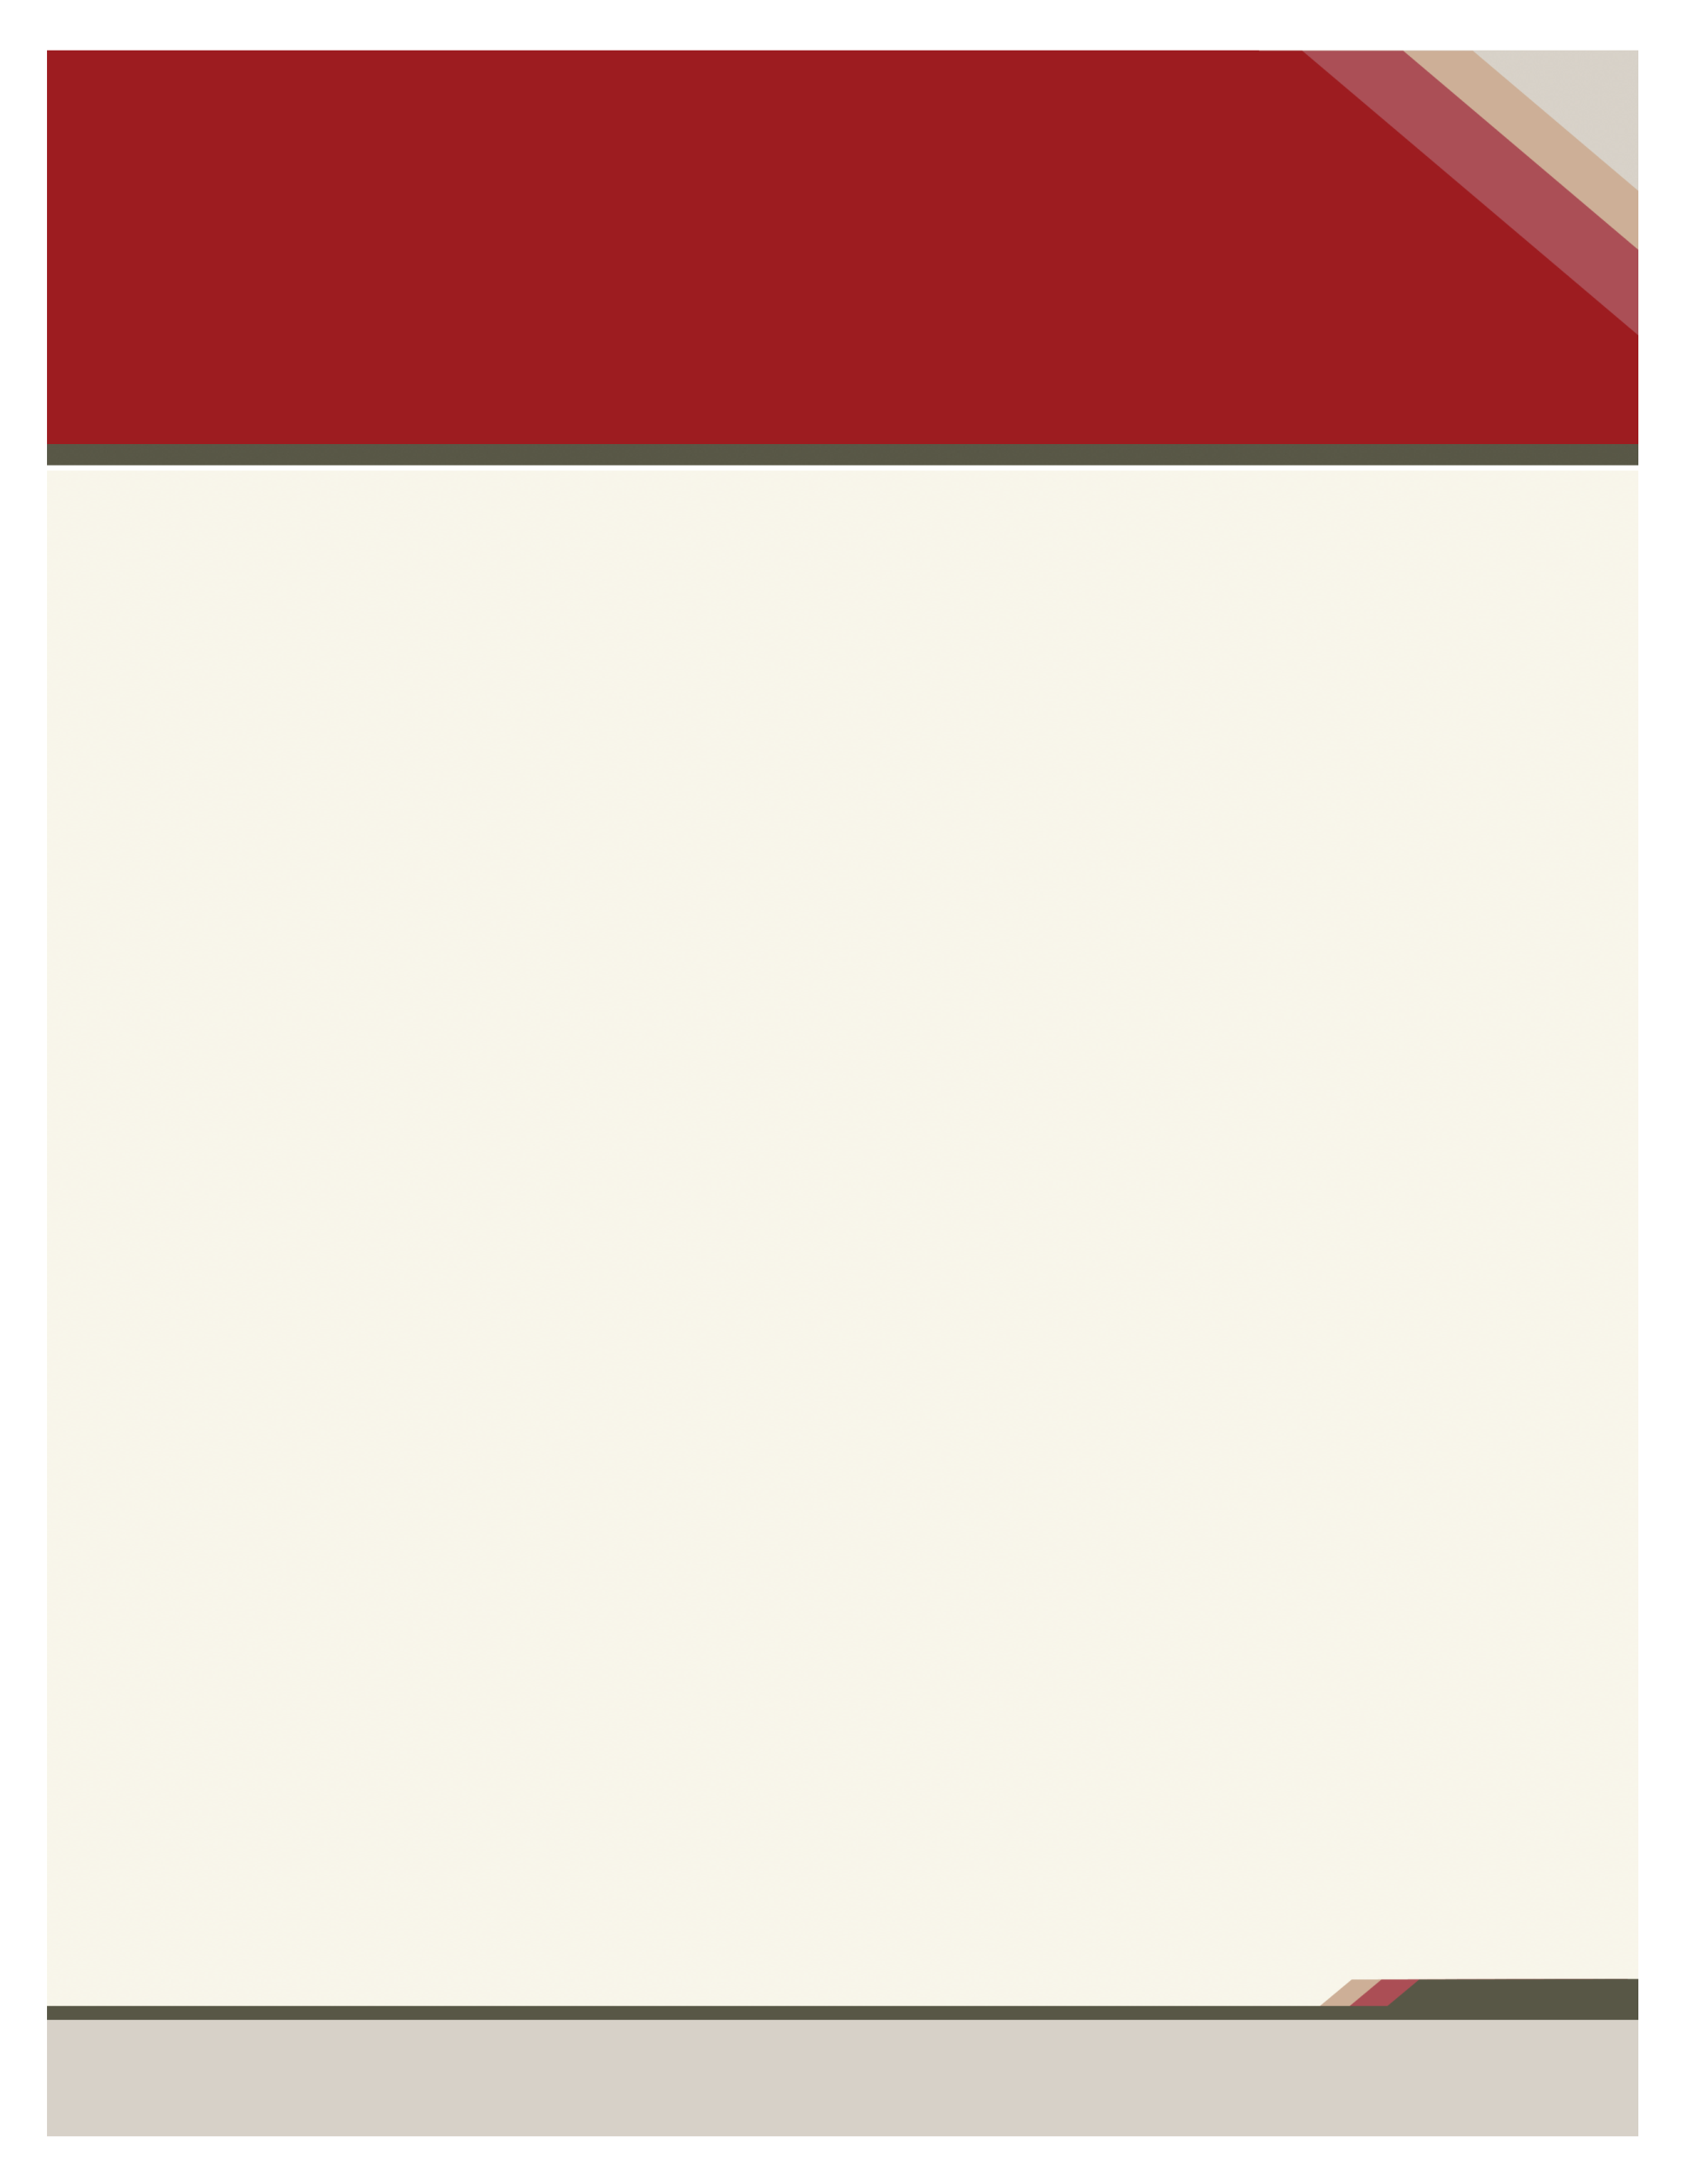

2023 PAAOHN Annual State Conference – April 26-27, 2023

SUBHEAD HERE

RESET AND ONWARD

Enter Contact Information Here | 1127 Lombard Blvd. San Francisco, CA 59802 | phone 555.555.5555 | fax 555.555.5555

­

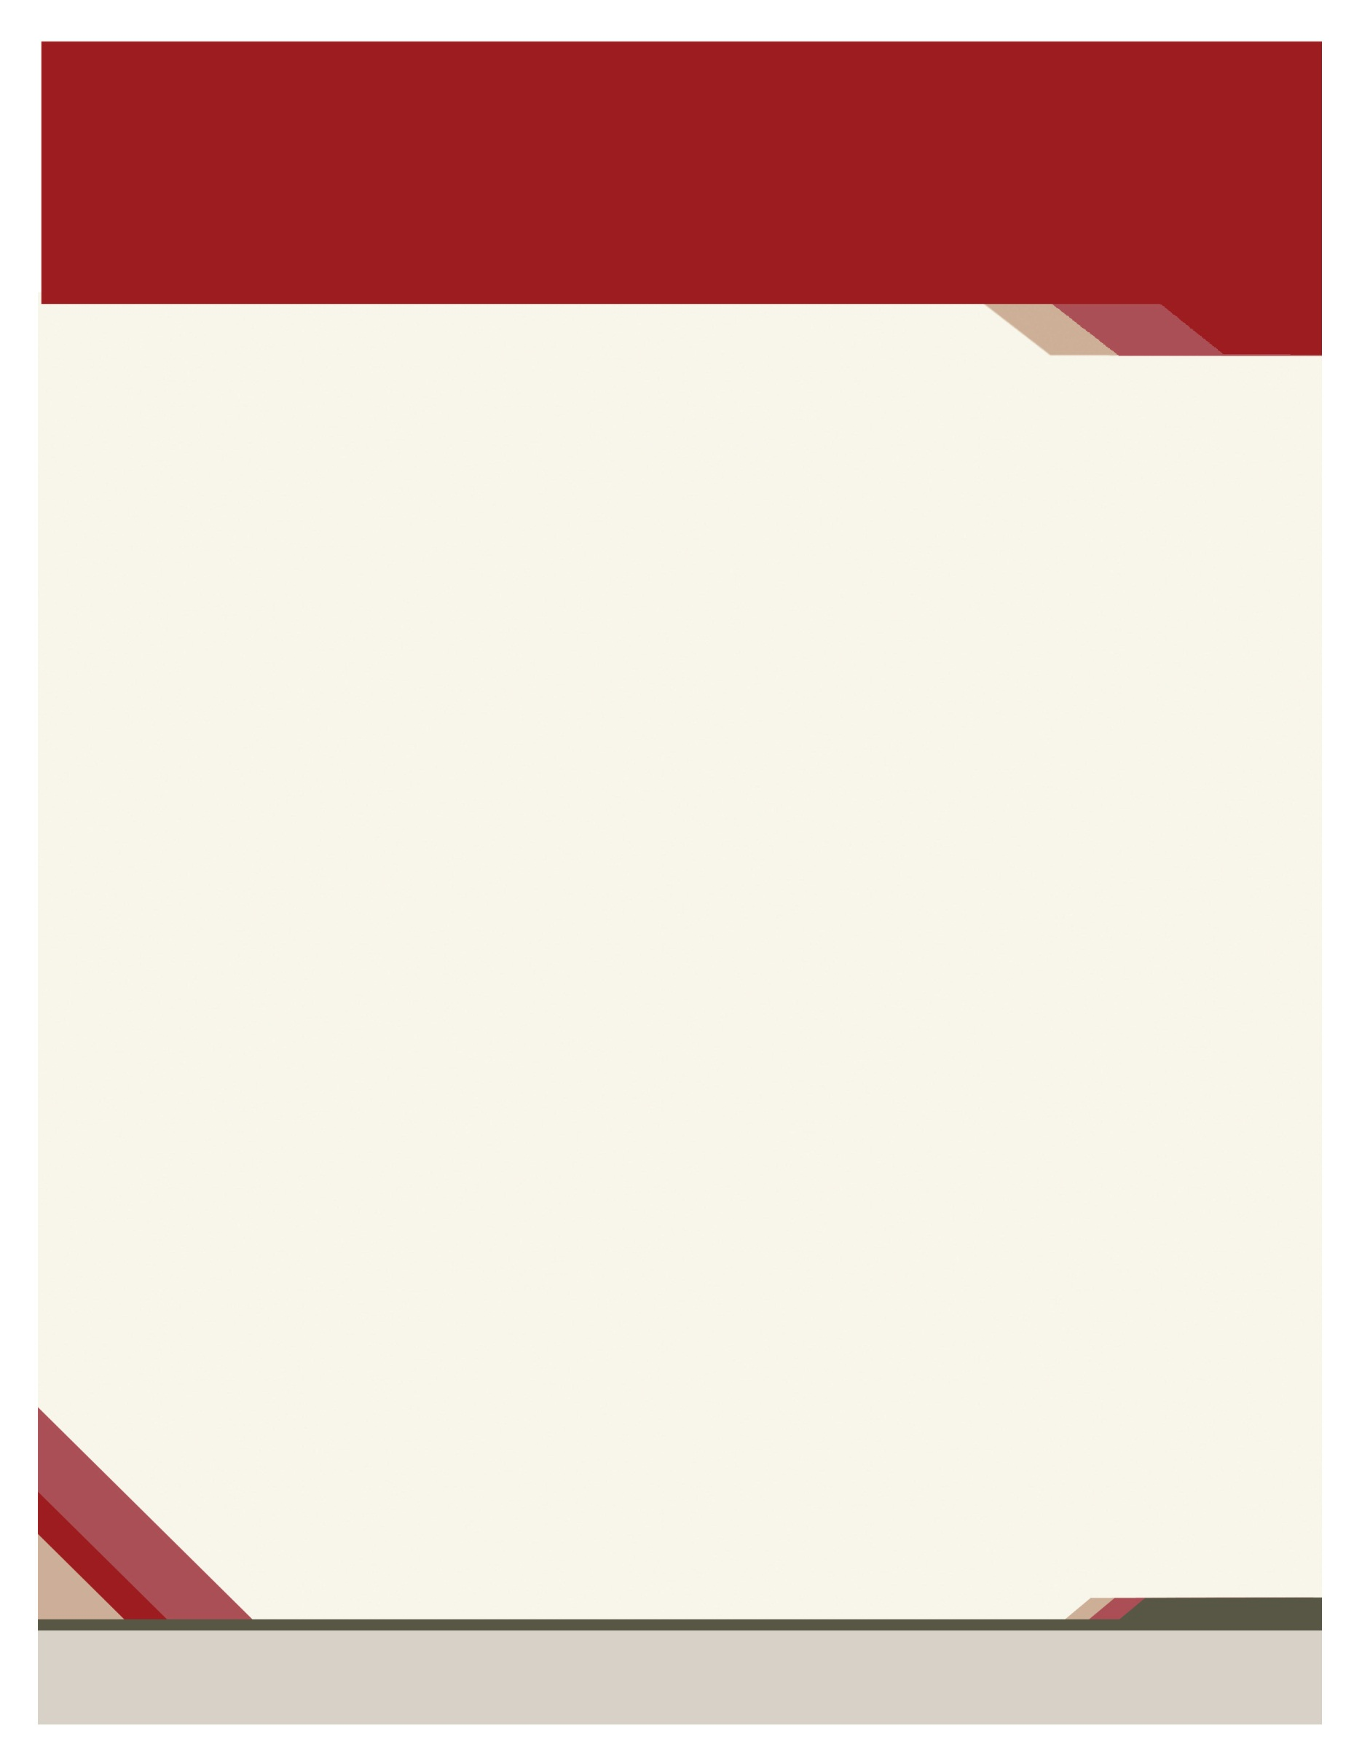No

**Disclosure statement**

There are no conflicts of interest affecting this continuing education activity. Participation will be verified by sign-in roster, completion of evaluation tool and completion of self- reported attendance verification forms

There is no commercial support for this activity

There is no implied endorsement of any commercial product by PAAOHN

There is no discussion of off label uses of drugs as defined by the FDA

**This activity has been submitted to the Montana Nurses Association (MNA)for approval to award contact hours. MNA is an accredited approver of continuing education by the American Nurses Credentialing Centers Commission on Accreditation.**

**This activity has been submitted to The Commission for Case Managers Certification for continuing education credit.**

Speakers

Alternative Medicine Efficacies

Health Literacy and The Cultural Awareness for Healthcare Practitioners

Tales of a Tired Healthcare Worker

Physical Therapy Treatment of Concussion

What’s That on Your Skin?

Worker’s Compensation: Post COVID Trends and Ethics

Strong Roots Grow Beautiful Leaves: a History of Occupational Health Nursing

Vaccine Hesitancy, Vaccine Acceptance, Anti-Vaccine: What’s the Difference?

Own The Value of Your Journey

Kim Olszewski, DNP, CRNP, COHN-S/CM, FAAOHN, FAAN

Ann Marie Loiseau, DNP, MS, RN, CSN, CCM

Andrea Mantione, DNP, MHA, CRNP, NP-C

Yolanda C. Lang, DrPH, MSN, CRNP, COHN, FAAOHN

Kim Wyand, PT, DPT

Lori Parke, MSN, DNP, CRNP

Troy L. Burd, BSN, RN, COHN-S, FAAOHN

Joanne Ludwikowski, Esquire

Crystal McFadden, LPC

Chad Rittle, DNP, MPH, RN, FAAOHN

**Mohegan Sun Pocono**

**1280 Highway 315**

**Wilkes-Barre, Pennsylvania 18702**

**570-831-2100**

**mohegansunpocono.com**

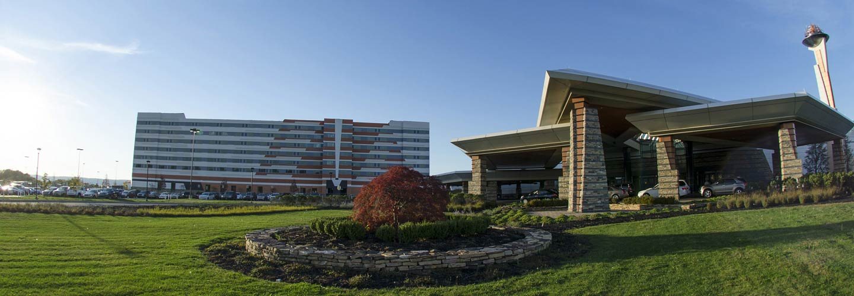

Please contact Troy Burd at [ptburd449@embarqmail.com](mailto:ptburd449@embarqmail.com) or 717-320-4326

Topics:

**Mohegan Sun Pocono**

King Deluxe Standard, Non-Smoking- $119

Queen Deluxe (2 beds) Non-Smoking - $129

Rate does not include applicable taxes and resort fees

**Website for Room Reservation**

<https://book.passkey.com/go/PAO0423>

**Amenities**

**Fitness Facilities**

**Indoor Pool**

**Free Self-Parking**

**Free Wireless Internet**

**Last day to register for the conference:**

**April 1, 2023**

**Charity To Be Announced**

This event offers 11.5 CNE units Applicable to your RN license

Online Registration will be available at: <https://paaohn.nursingnetwork.com/>

Please check the website for more information.

registration –

April 26-27, 2023

Name _____________________________

Credentials _________________________

Email ______________________________

Local Chapter _______________________

Company __________________________

Address ____________________________

Phone ____________FAX_____________

**REGISTRASTION FEES**

___ $225.00 – PAAOHN Member Full Conference

____ $300.00 Non-member Full Conference

____ $175 Retired Full Conference

____ One Day Fee –$150.00 each day

For more information, the Agenda of Speakers as well as full details of available awards and grants, please see our website below:

https://paaohn.nursingnetwork.com/

Registration fees include breakfast, lunch and CNE

Handouts will be available on line @

* https://paaohn.nursingnetwork.com/

Cancellations MUST be received by 3/30/23 and will be charged an administrative fee of $50.00