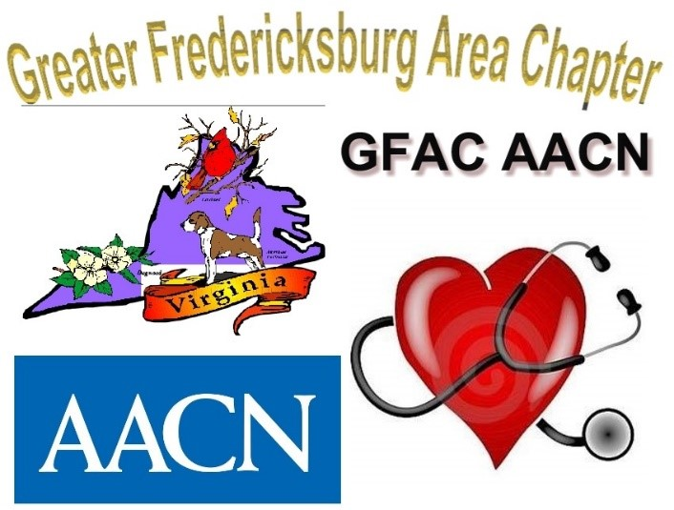

**GFAC-AACN Critical Care Symposium**

**Educational Dinner Event**

**Monday, March 20, 2023**

**3pm-8:15pm**

**John F. Fick III Conference Center**

1301 Sam Perry Blvd, Fredericksburg VA

on the Mary Washington Hospital Campus

**Topic: Sepsis – Oh SNAP!**

Surviving sepsis

**N**ursing interventions

**A**wareness

**P**erfusion

$40 – Includes dinner and CEU’s

(Proceeds go towards nursing school scholarships)

Register by March 10th via: gfacaacn.nursingnetwork.com

Please invite your nursing friends and co-workers!