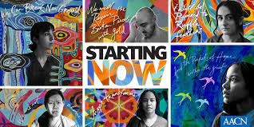
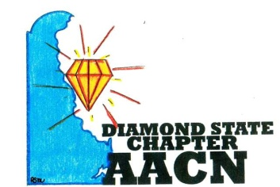

“Shine Bright Like A Diamond”
Agenda-December 13, 2022
Virtual
- Welcome
- Pending Business
  - Review of November minutes
  - Treasurer Report
  - Membership Committee
  - Recognition/Certification Committee
  - Social Media
  - Education Committee
    - Calendar
    - Vendors
    - CE
  - Volunteer Outreach
    - Calendar
    - Sepsis Proclamation
- CAT Updates - deferred
- NTI 2023 Philadelphia
- Wellness Check-in

Next meeting January 10, 2023 Christiana Hospital and Virtual with Pediatric Trauma lecture by Dr Emily Alberto

 | Month/Date | Location | Offering | Sponsor
2022 | October 11 | Christiana Hospital Meeting and Virtual | Dennis J Carradin – Stress, Trauma, and Coping in Healthcare | Kurin (Dinner)
2022 | November 8 | Paige Merring’s Home  349 Dillon Circle, Middletown DE  Dinner Meeting and Virtual | Volunteer Activity Blessing Bags for underserved populations | $10 participant fee for supplies  DSC (Dinner)
2022 | December 6 | Ryan Miller’s Home  154 Tuscany Drive  Middletown DE | Holiday Party | DSC
2022 | December 13 | Virtual only | Business Meeting
2023 | January 10 | Christiana Hospital  1303  Meeting and Virtual | Emily Alberto, MD – Pediatric Trauma
2023 | February 14 | Christiana Hospital  1303  Meeting and Virtual | Ray Blackwell, MD - ECMO
2023 | March 14 | Christiana Hospital  1303  Meeting and Virtual | Chris Otto – Healthy Nurse, Healthy Delaware
2023 | April 11 | Restaurant | Neuroptics speaker - Pupils | Neuroptics Kristen Flederback
2023 | May 9 |  | Megan Money and Lisa Markiewitz – Workship: How to plan and submit a poster abstract
2023 | June 13

Questions
- What type of contract do I need for April?
- CE for January? Pizza
- EZ IO proposed 15 minutes education on care and maintenance IO with link to 1.5 CE online. Wants to do after January 10 lecture, no sponsorship. Thoughts?
- Calls with Deborah Zehe regarding dinner meeting (seizure meds) and Chris Bennuhan NxStage
- Emailed about 10 vendors

Proposed topics
- Trauma
- ECMO – Dr Blackwell
- Preceptor and Leadership
- Developing a poster – maybe May or June for submission for 24 NTI?
- Sepsis
- Delirium, pharmacokinetics, ABC
- Antibiotics
Volunteer activities
- Ronald McDonald House
- Food Bank
- Soup Kitchen

