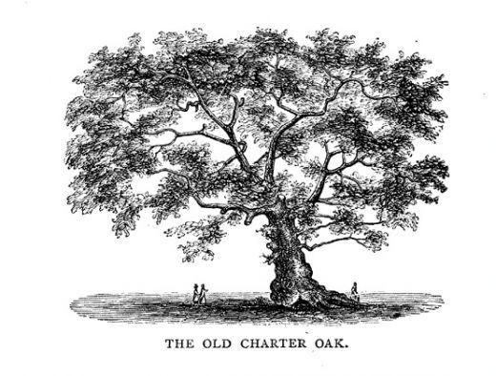

CT Charter Oak Chapter Elections to be held in December, 2022
Would you like to be a bit more involved in your local HPNA Chapter?
The Chapter is seeking RNs for the offices of Treasurer and Secretary. These two positions are voted on by the Chapter membership. The Chapter is also seeking someone to chair the Program Committee. Officers will begin Jan 1, 2023 and end Dec 31,2025. Each of these positions has a talented person in place and will help transition new officers.
This is your chance to be involved in growing this HPNA Chapter!
HPNA holds an Annual HPNA Team Conference, and our chapter will provide the registration fee to one lucky Board Member!

Treasurer: Has charge of the CT Chapter funds along with the Chapter President. The Chapter currently has a checking account only but is looking to add a Debit Card for our incidental expenses. The Treasurer collects bank statements for reporting in the National HPNA Annual Report. Chapter Board meeting once per month, 1 hour.
Secretary: Takes minutes during monthly Board meetings and Chapter membership meetings (approximately 4 per year). Disseminates minutes, posting online to NursingNetwork. Chapter Board meeting once per month, 1 hour.
Program Chair: Planning/organizing CT Chapter programs, 4 to 6 programs each year. The entire Board participates to identify appropriate programs and potential speakers. Working with CE coordinator for all CE offering programs. Programs may be virtual and or in person as necessary. Chapter Board meeting once per month, 1 hour.

