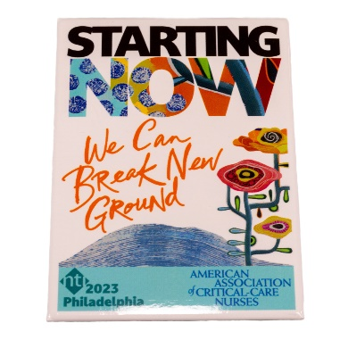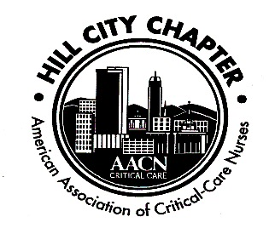

**The TIME IS NEAR Get your CEUS before the end of the year, REGISTER today before it is full**

***HILL CITY CHAPTER AACN***

**CRITICAL CARE CONFERENCE 2022**

***Thursday***

***DECEMBER 1,2022 0700-1700***

***First Colony Conference Room, LGH***

***Topics are being finalized but include AACN Theme Starting Now/ Implementing Healthy Work Environment Standards: Does it have to be so difficult? / What is the Long Covid Syndrome/ Current Healthcare Ethical Dilemmas/ Healthcare's Financial Viability, Innovative Staffing and Retention Post Covid/ Carotid Endarterectomy vs TCAR and the Barostim Neo for Heart Failure***

***Speaker(s)***

***Keynote Speaker Amanda Bettencourt- President of the American Association of Critical-Care Nurses, Rob Boesch, Dr David Cassada, Dr. Tim Spooner, Mike Gillette, Ph.D., Carrie White,***

**Register on Nursingnetwork.com**

POC Anne Marie Caylor 434-610-0156

Nurses of all specialties are invited.  The agenda will meet every nurse's needs and interests.   ***Contact hours are pending***. Continental Breakfast and Boxed Lunch and snacks included along with various door prizes.