Fff



Fall 2022

Volume XXXVII Issue 2

Inside the Issue:

President’s Address

VSPAN Conference Notes

Interested in Submitting an Article, Editorial, or Education Material? Here’s How!

ABPANC Information

CAPA/CPAN Certification Information

Government Affairs Update

VSPAN Information

Board Members Contact Information

District Contact Information

VITAL TIMES

**President’s Message**

Five years ago, after returning home from another great VSPAN Annual Conference at the beach, I got a phone call out of the blue. It was Carolyn Tucker, the president of VSPAN, asking me to get involved with the board as a representative for the northwestern district. It had never occurred to me to join the board, but I’m so glad that she asked. I’ve learned a lot, gotten to know some great people, and I’ve been honored to help provide perianesthesia nurses across Virginia with continuing education, scholarships, and networking opportunities. I never would have predicted it five years ago, but now I’m writing to you as the new VSPAN President!

A lot has changed in the last few years, including adapting to virtual events instead of in person, however that’s not a bad thing. Zoom has enabled many nurses to participate in our conferences who otherwise would not be able to afford the time or travel to attend in person. So while we transition back to in person events in the coming year, I believe we need to maintain the virtual options as well. I know everyone has busy lives and many hospitals and surgery centers are still struggling daily with adequate staffing. Your available time is limited so let’s make it as easy as possible for us to connect.

I’d also like to suggest that we take advantage of an untapped resource—each other. There is so much great work being done by VSPAN members that could be of value to other nurses at other institutions as well. I want to hear about your evidence based practice projects, research, and other successes and innovations. Were you able to streamline the onboarding for travelers in your PACU? I guarantee there are others who want to learn from your experience instead of starting from scratch to accomplish the same goal. Did you create a mailbox in service for your staff? Share it by turning it into an article for the Vital Times newsletter. We can help each other to “work smarter, not harder.”

VSPAN must continue to evolve to stay relevant and valuable to our members. We will continue to provide the conferences, webinars, and scholarships you count on. And we welcome your ideas about what else we can do to meet your needs as a perianesthesia nurse. Share your successes and your suggestions by contacting us through our [website](https://virginiaspan.nursingnetwork.com/contact) or our [Facebook page](https://www.facebook.com/vspan2018).

We look forward to hearing from you!

Sincerely,

Amy Ballenger BSN RN CPAN

VSPAN President

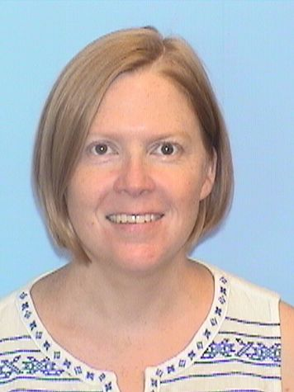



Our 2022 VSPAN Conference was a success!

Thank you to Melanie and Carolyn for all of your hard work!

Topics Reviewed:

* Understanding the Effects of Trauma on Health
* What is LAST and are you Prepared?
* Pseudocholinesterase Deficiency
* Black Maternal Health Disparities and the CRNA
* A Multidisciplinary Approach to Post-operative Pediatric Pain Management
* Peripheral Nerve Blocks
* Noise Reduction in the OR: How can we Protect the Mental Health of the Veteran During Surgery

Thank You to all of our Speakers!

Interested in Submitting an Article, Editorial, or Education Material?

Here’s How!

This May, Chris and I virtually attended the annual American Pediatric Surgical Nurses Association (APSNA) Conference, and wanted to share some interesting info we learned! The presenter, Anita Catlin, PhD, FNP, CNL, FAAN emphasized that there are many different types of writing that can be published in a scientific journal, including but not limited to:

•         Letter to the Editor/Op-Ed for a nursing journal or a community newspaper

•         Opinion Piece, Editorial (e.g. career guidance and support)

•         Narrative piece, poem, story

•         Clinical review (e.g. new surgical procedure and how the procedure impacts the care that the patient receives across the perioperative continuum; care of special patient populations such as refugees, neurodivergent patients, and patients with behavioral health comorbidities)

•         Case Study (e.g. an interesting or challenging case that was encountered in practice; ethical challenges encountered in the practice environment)

•         Project (healthcare provider resiliency and self-care; how a particular nursing theoretical framework impacts the care of patients)

•         Research

•      Healthcare Management

So many options! After figuring out what you want to write about, you can use this link to help you find a nursing journal:

-       <https://airtable.com/shrjqveaKHtS9xku8/tblNXTxmTr18CC1If>

A few journals that are relevant to our setting include the Journal of PeriAnesthesia Nursing, Journal of Pediatric Surgical Nursing, and Anesthesia eJournal, but you can also look into publishing in a more general nursing journal such as Journal of Pediatric Nursing, American Journal of Nursing and many others. Publishing doesn’t have to be limited to a nursing journal either; there are tens of thousands of medical journals that publish nursing-specific articles.  Also, you can write an editorial or Op-Ed for a newspaper addressing healthcare topics.

After choosing what to write and looking into journals, you can typically find out the journals acceptance rate by googling the journals name and “acceptance rate”. For example, see the picture below for the acceptance rate for the Journal of PeriAnesthesia Nursing, which was 37% in 2021.

​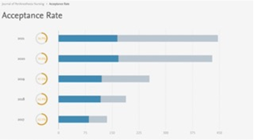

Once you’ve chosen a few journals to possibly submit to, you can email the editor of the journal to inquire about interest in your article. Start by explaining what you would like to write/submit and why, and explain that you are writing to see if it is something that the journal would be interested in publishing. This step isn’t required, but it helps to get a sense of which journals would be open to reviewing your piece.

The journal’s website should have author guidelines that will help you as you write.

If you’re planning on writing a research article or literature review analysis, there are countless resources for conducting literature reviews and writing original research proposals. For example, the ASPAN website has research/clinical inquiry resources including the following document that provides a comprehensive guide for conducting nursing research:

-       [Microsoft Word - Research Primer 2018 Edited 4.16.2018.docx (aspan.org)](https://www.aspan.org/Portals/88/Research/Primer/Research_Primer_2018_Edited_0518.pdf?ver=laChstLapKqpphYZlRVsww%3d%3d)

If you are writing a research article or literature review, there are multiple citation management software packages available to assist you with generating your bibliography.  Dr. Catlin recommended EndNote for citation management for the following reasons:  it permits you to format your bibliography based on the journal’s formatting requirement; and, it is user friendly for the novice author.

Regardless of your topic or type of article, everyone has something to contribute that can benefit patients and healthcare professionals alike! Plus, getting your writing published can help you stand out if you’re planning on advancing your career/education.

*Annika Rhinehart, BSN, RN, CPAN*

*Clinician II, Outpatient Surgery Center*

*University of Virginia Health System*

[Ar4ef@uvahealth.org](mailto:Ar4ef@uvahealth.org)

Christopher Kremer, RN, BSN, CAPA

Clinician III, Outpatient Surgery Center

University of Virginia Health System

[Csk9n@uvahealth.org](mailto:Csk9n@uvahealth.org)

**The Funny Pages**

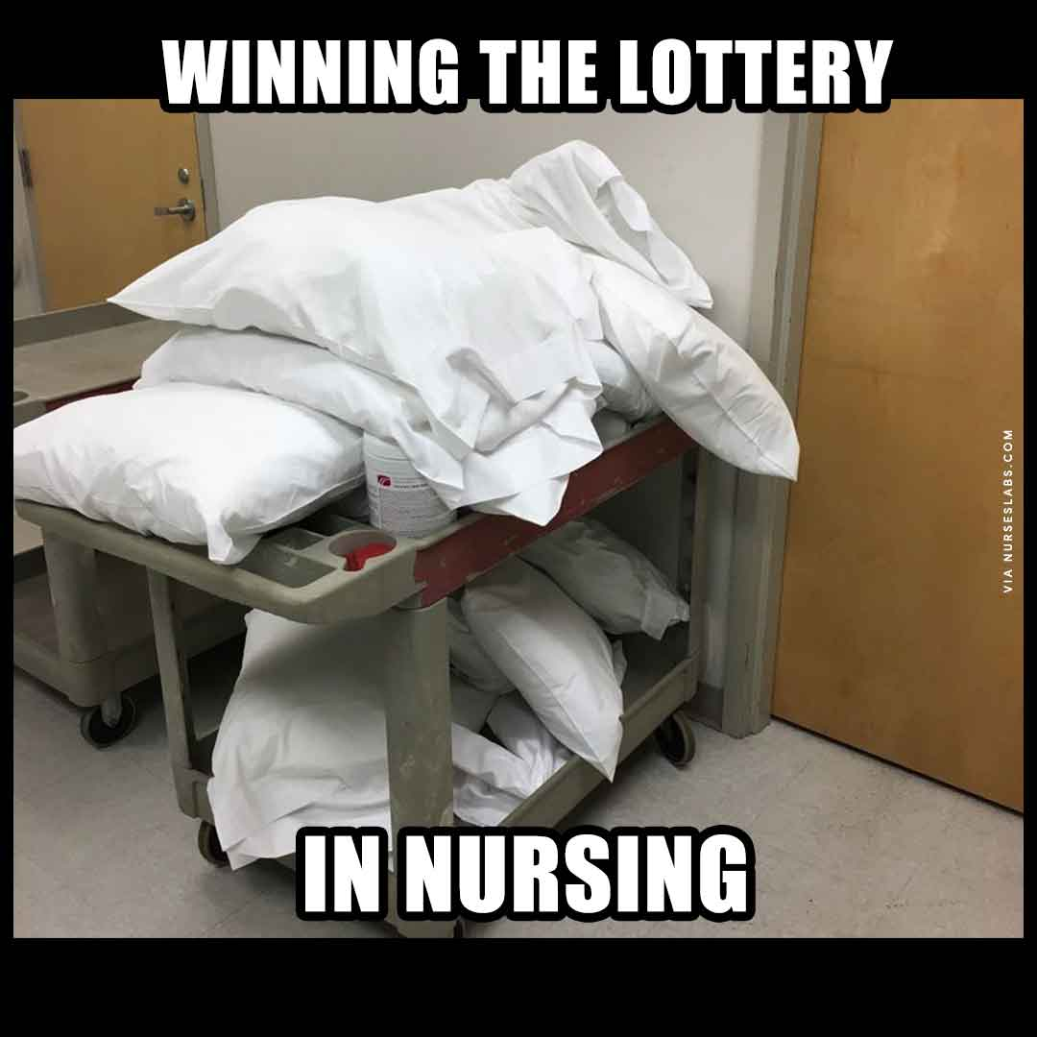

Do you have a question about patient safety or best practice?



Contact the Clinical Practice Committee at ASPAN via email and they will confidentially respond to your inquiry.

Check the FAQ page for information at [Clinical Practice FAQs (aspan.org)](https://www.aspan.org/Clinical-Practice/Clinical-Practice-Frequently-Asked-Questions)

**ABPANC INFO**

Need help to get ready for the CAPA or CPAN exam? Contact one of the volunteer ABPANC Certification Coaches in Virginia:

Laurie Waldron [lashton31@yahoo.com](mailto:lashton31@yahoo.com)

Alicia White [alicia3kids52@yahoo.com](mailto:alicia3kids52@yahoo.com)

Rebecca Gilbert rg4w@uvahealth.org or [nursecivility@gmail.com](mailto:nursecivility@gmail.com)

Amy Ballenger alb3w@uvaheath.org

Donna Goyer dmgoyer@carilionclinic.org

Katie Scully [kathryn.scully@inova.org](mailto:kathryn.scully@inova.org)

[Contact ABPANC - American Board of Perianesthesia Nursing Certification, Inc. (cpancapa.org)](https://www.cpancapa.org/about/contact-us/)

SAVE THE DATE!!!



CAPA/CPAN Spring Exam Registration

January 1- April 30

Exam Administration Window

March 15- May 15

[Nursing Certification Schedule and Fees - CPAN® and CAPA® Certification (cpancapa.org)](https://www.cpancapa.org/become-certified/schedule-fees/)

**Fall Government Affairs Update**

Fall is election season and the most important action you can take is to Vote! This fall includes not only the national mid-term elections but important local and state elections as well. By the time this article is published, we will be aware of the results and ready to continue our advocacy work with new as well as returning legislators.

The Nursing Community Coalition (NCC) remains the primary legislative resource for nursing at the national level. The NCC represents 63 professional nursing associations that are committed to improving healthcare and the health of our communities through the support of nursing education and practice of RN’s and APRN’s. On September 26, 2022, the NCC submitted a letter to Congress highlighting the following priorities for nursing:

* **Invest in Nursing Education Pathways**- Cosponsor and Pass the Future Advancement of Academic Nursing (FAAN) Act (S.246/H.R.851) which would provide resources to support nursing students, retain and hire diverse faculty, and create and expand clinical education opportunities.
* **Make Waivers that have supported our Nation’s Health during this Public Health Emergency Permanent**. By doing so, the models of care implemented during the pandemic would become permanent and allow nurses and APRNs to continue to provide high quality health care to patients in all communities, including rural and underserved areas.
* **Invest in Maternal Health- Cosponsor and Pass the Black Maternal Health Momnibus Act (H.R.959/S.346) and the Midwives for MOMs Act (H.R.3352/S.1697).** These bills would provide for investing in social determinants of health and growing a diversified perinatal workforce as part a multipronged approach to addressing the maternal health needs of the nation.

Also in September, the NCC sent a letter to the House Appropriations Committee requesting the support of funding levels of at least $324.472 million for Nursing Workforce Development Programs (Title VIII of the Public Health Service Act [42 U.S.C. 296 et seq.]) and at least $208.571 million for the National Institute of Nursing Research (NINR, National Institutes of Health) in Fiscal Year (FY) 2023. These funds support nursing education, workforce development and research.

This information and much more is available on the Nursing Community Coalition website ([www.thenursingcommunitiy.org](http://www.thenursingcommunitiy.org))

Virginia’s legislative priorities can also be found in their website ([www.virginianurses.com](http://www.virginianurses.com)). Some of their top priorities include:

* **Continue Funding for the Virginia Preceptor Incentive Program***.*  The 2021 General Assembly appropriated $500,000 to VDH for one year to provide financial incentives for healthcare professionals who serve as preceptors (hands-on clinical instructors) for APRN students. By continuing this funding, Virginia can increase student enrollment and focus on underserved areas, particularly the high demand positions in primary and psychiatric care.
* **Reduce Unnecessary Practice Restrictions**. At the start of the pandemic, Governor Northam issued an executive order to reduce the time a nurse practitioner is required to practice under a physician practice agreement from 5 years to two. This was later passed through the General Assembly however the provision expired July 1, 2022. The goal is to have this reduced timeframe become permanent and in line with other states requirements.

* **Extend COVID-19 Presumption for Healthcare Workers***.* In 2021 legislation was adopted providing a presumption of work-related infection for healthcare professionals who contracted Covid 19 through their work with confirmed or suspected COVID-19 patients. Extending this presumption would allow for some peace of mind for healthcare workers who must provide care to all, regardless of patient vaccination status.
* **Clarify Prescriptive Authority Law for Clinical Nurse Specialists**In 2021, legislation was passed that provided clinical nurse specialists (CNSs) with prescriptive authority. An unintended consequence of this change was that all CNSs had to enter into a practice agreement with a physician, even if they did not want to prescribe medication. The General Assembly should clarify the law to allow CNSs the option to practice without collaborative agreements if they do not wish to prescribe.
* **Registered Nurses in Public Schools**School nurses are essential in communicable disease surveillance, identification, and intervention as well as meeting many health needs for students. The ongoing goal is to ensure there is one registered nurse in every school across Virginia.

ASPAN’s President Connie Hardy-Tabet has established a Collaborative Advocacy Strategic Work Team (CASWT) led by Elizabeth Card and LeighAnn Chadwell. As the ASPAN Government Affairs SWT coordinator, I am a member of the CASWT. We held the second Zoom meeting on 10/20/22, finalizing the Charter and defining next steps. Dr. Elizabeth Card will be sharing more about collaborative advocacy during the Perianesthesia Development Institute (PDI) in November and be on the lookout for more information in a future edition of *The Breathline*. This SWT will be another strong resource for advancing ASPAN in research, education, and advocacy!

Respectfully,

Donna Goyer BS, RN, CPAN, CAPA

ASPAN GA SWT Coordinator 2022-2023

VSPAN GA Chair 2022-2023

**VSPAN Mission:**

VSPAN will be recognized in Virginia as a leading association and resource for Perianesthesia Nursing education and practice.

**VSPAN Goals:**

VSPAN will align and function with ASPAN’s Core Values.

CARES-Courage. Advocacy. Respect. Excellence. Service.

.

VSPAN Mailing Address

VSPAN

**C/o Leanne Davis**

**PO Box 371**

**Louisa, VA 23093**

Articles/Pictures/Submissions for Vital Times:

Elaine Hughes- [emo2j@uvahealth.org](mailto:emo2j@uvahealth.org)

VSPAN Website: Virginiaspan.nursingnetwork.com

**VSPAN Board of Directors Contact Information**

**President**  
*Amy Ballenger, BSN, RN, CPAN – alb3w@uvahealth.org*

**Vice President/ President-Elect**  
*Vacant*

**Immediate Past President**

*Pam Champigny, MSN, RN -pamelachampigny@yahoo.com*

**Secretary**  
Melanie Prince, BSN, RN, CCRN-bloughm@comcast.net

**Treasurer**

Leanne Davis, MSN, RN, CPAN – lnc6t@uvahealth.org

**Membership Chair**  
Alicia White, BSN, RN, CAPA – arw9v@uvahealth.org

**Publications (Newsletter Editor)***Elaine Hughes, BSN, RN, CAPA – emo2j@uvahealth.org*

**Education Chair**  
[*Carolyn Tucker, BSN*](mailto:cwtucker@sentara.com)*, RN- cwtucker@sentara.com*

**State Conference Co-chair**

Melanie Prince, BSN, RN, CCRN- *bloughm@comcast.net*

**By-Laws/Policies & Procedures Chair**  
Amy Ballenger, BSN, RN, CPAN

**Public Relations/Marketing**  
Leanne Davis, MSN, RN, CPAN

**Government Affairs Chair**   
[*Donna Goyer, BS, RN, CPAN, CAPA*](mailto:dmgoyer@carilionclinic.org)*- dmgoyer56@gmail.com*

**Ways & Means Chair**  
*Vacant*

**Historian**  
vacant

**VSPAN District Contacts**

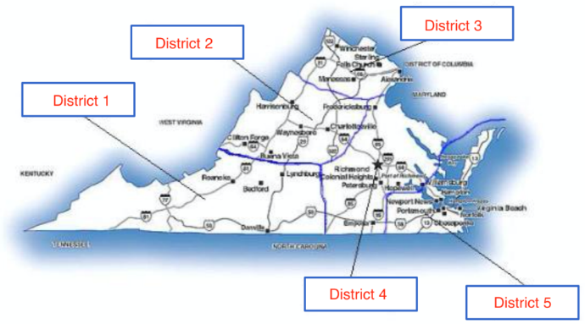

**District 1 - Southwestern Virginia**  
Roanoke/Lynchburg/Danville/Bristol  
Lori Servas, BSN, RN IV, CPAN  
*Loribell216@aol.com*

*&*

Tiffany Mayhorn, MSN, RN *tgmayhorn@gmail*.com

**District 2 - Northwestern Virginia**  
Harrisonburg/Waynesboro/CharlottesvilleAmy Ballenger BSN RN CPAN *ALB3W@uvahealth.org*

**District 3 - Northern Virginia**  
Winchester/Sterling/Falls Church/Manassas/Alexandria  
*Katie Scully- Kathryn.scully@inova.org*

**District 4 - Central/Northeastern Virginia**  
Richmond/Petersburg/Emporia  
Pam Champigny, MSN, RN  
[*pamelachampigny@yahoo.com*](mailto:pamelachampigny@yahoo.com)

**District 5 - Southeastern Virginia**  
Williamsburg/Chesapeake Bay/Virginia Beach/Norfolk/Newport News  
Carolyn Tucker, BSN, RN  
*cwtucker@sentara.com*