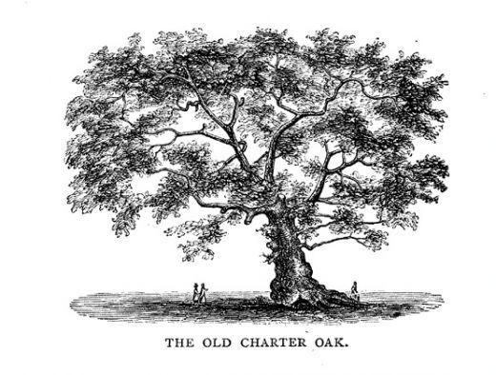

The CT Charter Oak Chapter of the HPNA Presents:
“Guiding Your Patient Through Advance Care Planning Conversations”
With Karen Mulvihill APRN and Julia MacMillan APRN
Date: November 10, 2022
Time: 5:45 -6 PM Membership Business Meeting
6:00 - 7 PM Program Place: Middlesex Hospital
28 Crescent St., Middletown, Ct.
Baggish Conference Room

Zoom link on page 2 for those who cannot attend in person

Continuing Education credits provided by Middlesex Health


Accreditation Statement: Middlesex Health is accredited by the Massachusetts Medical Society to provide continuing medical education for physicians.
Credit Designation: Middlesex Health designates this live activity for a maximum of 1 AMA PRA Category 1 Credit™. Physicians should claim only the credit commensurate with the extent of their participation in the activity. Middlesex Health designates this live activity for a maximum of 1 Attendance w/ No Credit. Physicians should claim only the credit commensurate with the extent of their participation in the activity.
Series Disclosures: No disclosures.
Event Disclosures: There are no relevant financial relationships with ACCME‐defined commercial interests for anyone who was in control of the content of the activity. Commercial Support: This activity is not commercially supported.

Target Audience: RN’s, ICU and Med-Surg RN’s and all hospice and palliative staff. Social workers and other allied healthcare workers also welcome

Join Zoom Meeting
https://hpna-org.zoom.us/j/87014615698?pwd=VjFFU0VIbDFqR0VFMGFCeGNBTW9tUT09
Meeting ID: 870 1461 5698
Passcode: 763170
One tap mobile
+13126266799,,87014615698# US (Chicago)
+16469313860,,87014615698# US
Dial by your location
+1 312 626 6799 US (Chicago)
+1 646 931 3860 US
+1 929 205 6099 US (New York)
+1 301 715 8592 US (Washington DC)
+1 309 205 3325 US
+1 669 900 6833 US (San Jose)
+1 719 359 4580 US
+1 253 215 8782 US (Tacoma)
+1 346 248 7799 US (Houston)
+1 360 209 5623 US
+1 386 347 5053 US
+1 564 217 2000 US
+1 669 444 9171 US
Meeting ID: 870 1461 5698
Find your local number: https://hpna-org.zoom.us/u/keD0Iil20p

