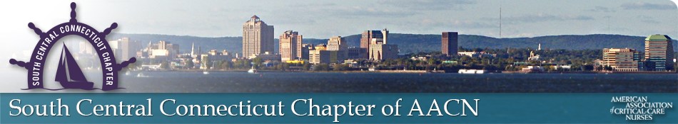

Please join SCCC-AACN for our Live Educational Event

**Did I Really Write That?**

**Protecting You and Your Colleagues**

Presented by

**Melinda Monson MSN, RN, Esq**.

**Wednesday November 9, 2022**

**6 pm - 9pm**

Brewport Brewing Company

225 Frontage Road Bridgeport, CT

Pizza, Salad, Dessert Provided

SCCC-AACN Members $20

Non Members $30

To register please visit our website

Registration closes November 1, 2022; Walk-ins Welcome <https://scccaacn.nursingnetwork.com/>

For Questions Please Email: lynnorser@sbcglobal.net

**This nursing continuing professional development activity was approved by the American Association of Critical-Care Nurses, an accredited approver by the American Nurses Credentialing Center’s Commission on Accreditation.**