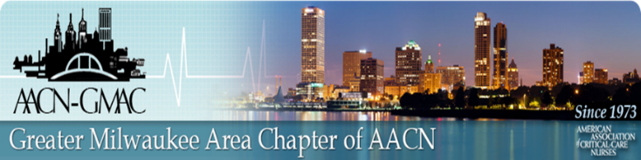

**Virtual Education Session**

**OCTOBER 25, 2022**

**AACN Theme:**

**“Starting Now”**

by:

Amanda Bettencourt, PhD, APRN, CCRN-K, ACCNS-P

AACN President

Program:

7:00 p.m. AACN-GMAC Welcome and Announcements

7:05 p.m. Presentation

**This is a FREE event. All participants need to register for zoom link:**

[*https://us02web.zoom.us/webinar/register/WN_l2hMvFTBQEq_9xcEqTqWrg*](https://us02web.zoom.us/webinar/register/WN_l2hMvFTBQEq_9xcEqTqWrg)

*Link for evaluation and CE will be provided after the session.*

Objectives:

•Describe this year’s AACN theme of “Starting Now”

• Discuss the rationale for using actions to heal and move forward

• Evaluate the barriers to change

• Identify techniques that promote positive change

• Discuss ways to integrate the theme of “Starting Now” into personal and

professional growth opportunities