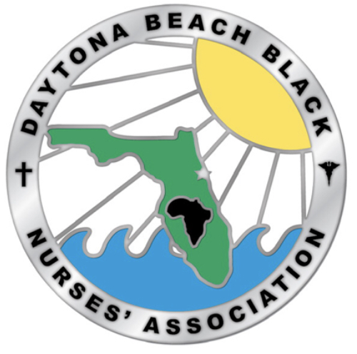

|  |
| --- |
| Hi Family & Friends  Fighting breast cancer is very personal to me, and that’s why I have joined the Making Strides Against Breast Cancer movement in my community. You can support it too by helping me reach (or exceed!) my fundraising goal. Every dollar I raise will directly support the American Cancer Society’s innovative breast cancer research, help provide free 24/7 information and support, ensure greater access to quality care, influence public policy, and provide direct support to breast cancer patients and their families.  Thanks to decades of work, a breast cancer diagnosis does not come without hope, and the breast cancer journey is not one that is traveled alone. Those who are newly diagnosed, survivors, and thrivers are depending on us to continue to fight for them and a future free from breast cancer. I am proud to take on that challenge and truly appreciate your support.  Thank you so much. |

[**Click here to visit my PERSONAL page.**](https://urldefense.com/v3/__http:/main.acsevents.org/site/TR?px=48516522&pg=personal&fr_id=103063&s_locale=en_US&et=cssYIx_NKxqdPa9unqXm9rEar-enLMPBxgEWNwoD8u0XI4dxv_QDFA__;!!LXKydnYPWvo3!DqoSN3RskGnAWuGFNoC2sULfa-s6rheJEEQ3eMQEYzVE1MJA1Ldb8Pb5zW-kYWH15nS8P_oB0_RyT3Nim5Y4T7uyeCaoosXo$)  
If the text above does not appear as a clickable link, you can visit the web address:   
[http://main.acsevents.org/site/TR?px=48516522&pg=personal&fr_id=103063&s_locale=en_US&et=cssYIx_NKxqdPa9unqXm9rEar-enLMPBxgEWNwoD8u0XI4dxv_QDFA](https://urldefense.com/v3/__http:/main.acsevents.org/site/TR?px=48516522&pg=personal&fr_id=103063&s_locale=en_US&et=cssYIx_NKxqdPa9unqXm9rEar-enLMPBxgEWNwoD8u0XI4dxv_QDFA__;!!LXKydnYPWvo3!DqoSN3RskGnAWuGFNoC2sULfa-s6rheJEEQ3eMQEYzVE1MJA1Ldb8Pb5zW-kYWH15nS8P_oB0_RyT3Nim5Y4T7uyeCaoosXo$)

[**Click here to view the TEAM page for DBBNA Achievers**](https://urldefense.com/v3/__http:/main.acsevents.org/site/TR?team_id=2656178&pg=team&fr_id=103063&s_locale=en_US&et=lLnLSjEiCCBt_qkx_qIyv16e98HukimNaUzqRE5WWsm2B_tlRpbM6A__;!!LXKydnYPWvo3!DqoSN3RskGnAWuGFNoC2sULfa-s6rheJEEQ3eMQEYzVE1MJA1Ldb8Pb5zW-kYWH15nS8P_oB0_RyT3Nim5Y4T7uyeAsWXSmD$)  
If the text above does not appear as a clickable link, you can visit the web address:   
[http://main.acsevents.org/site/TR?team_id=2656178&pg=team&fr_id=103063&s_locale=en_US&et=lLnLSjEiCCBt_qkx_qIyv16e98HukimNaUzqRE5WWsm2B_tlRpbM6A](https://urldefense.com/v3/__http:/main.acsevents.org/site/TR?team_id=2656178&pg=team&fr_id=103063&s_locale=en_US&et=lLnLSjEiCCBt_qkx_qIyv16e98HukimNaUzqRE5WWsm2B_tlRpbM6A__;!!LXKydnYPWvo3!DqoSN3RskGnAWuGFNoC2sULfa-s6rheJEEQ3eMQEYzVE1MJA1Ldb8Pb5zW-kYWH15nS8P_oB0_RyT3Nim5Y4T7uyeAsWXSmD$)

http://main.acsevents.org/site/PixelServer?tr=J0-K6OrTF5wUhbgq4LBl_-oqoXjFZB0SYAnnQAgXPQv5M7MkfaiKiQ

This message has been sent by a friend who thought you would be interested in information about the American Cancer Society's special events. If you no longer wish to receive emails messages sent from your friends, family members or colleagues on the subject of the American Cancer Society's special events, please [click here](https://urldefense.com/v3/__http:/main.acsevents.org/site/TellFriendOpt?action=optout&toe=71cfb1fcf3918e0371f8c139674d8239baecf7b05b975b26c157793613dbaef5__;!!LXKydnYPWvo3!DqoSN3RskGnAWuGFNoC2sULfa-s6rheJEEQ3eMQEYzVE1MJA1Ldb8Pb5zW-kYWH15nS8P_oB0_RyT3Nim5Y4T7uyeKhauTr6$) or paste this URL into your browser: [http://main.acsevents.org/site/TellFriendOpt?action=optout&toe=71cfb1fcf3918e0371f8c139674d8239baecf7b05b975b26c157793613dbaef5](https://urldefense.com/v3/__http:/main.acsevents.org/site/TellFriendOpt?action=optout&toe=71cfb1fcf3918e0371f8c139674d8239baecf7b05b975b26c157793613dbaef5__;!!LXKydnYPWvo3!DqoSN3RskGnAWuGFNoC2sULfa-s6rheJEEQ3eMQEYzVE1MJA1Ldb8Pb5zW-kYWH15nS8P_oB0_RyT3Nim5Y4T7uyeKhauTr6$)