7:00 – 7:50 Registration and Continental Breakfast

7:50 – 8:00 Welcome

Teresa Dudley, MSN, RN, CPAN

KSPAN President

8:00 – 9:00 Preventing Opioid Misuse in the PeriAnesthesia Setting

9:00 – 9:15 Break

9:15 – 10:15 Optimizing the Management of Opioid Tolerant Patients

10:15—10:30 Break

10:30 – 11:30 Current Trends in Nursing

Jan Odom-Forren, PhD, RN, CPAN, FASPAN, FAAN

11:30 – 12:30 Lunch

12:30 – 1:30 Post Anesthesia Pain Management

Dr. Jeffrey R. Graves

1:30 – 1: 45 Break

1:45 – 2:45 What we know about WAG: PACU Exposure and Management

Dr. Katherine D. Simpson, DNP, MSN, APRN-C, CNRN, CVRN-II, LNC

2:45—3pm Break

3:00 – 4pm Implicit Bias: What Lies Beneath the Surface

Karen Pierce MSN, RN, MAT

4 :00-4:15 Break

4 :15— 5:15 Reiki

Beth Bersot RN, CAPA

5:15- 5:30 Closing and Evaluations

Objectives

At the end of the program, the participants will be able to:

* Discuss important opioid safety information for the discharged surgical patient.
* Discuss evidence-based approaches to perioperative pain management for the opioid tolerant patient.
* Review current trends in nursing including the effects of Covid-19 and an impending nursing shortage.
* Define Pain
* Identify pain types
* Discuss common acute pain treatments
* Identify what causes WAG
* Explain how WAG enters the PACU environment
* Identify risks to nursing professionals
* Recognize side effects
* Identify safety measures and management
* To describe the benefits of Reiki
* To identify the uses of Reiki in Hospitals
* To understand the use of Self Reiki



Hilton Garden Inn, 1530 Alliant Ave, Louisville, KY 40299

[https://www.hilton.com/en/book/reservation/deeplink/?ctyhocn=SDFLEGI&tid=10504292&groupCode=KSP&arrivaldate=2022-10-14&departuredate=2022-10-16&cid=OM,WW,HILTONLINK,EN,DirectLink&fromId=HILTONLINKDIRECT](https://nam10.safelinks.protection.outlook.com/?url=https%3A%2F%2Fwww.hilton.com%2Fen%2Fbook%2Freservation%2Fdeeplink%2F%3Fctyhocn%3DSDFLEGI%26tid%3D10504292%26groupCode%3DKSP%26arrivaldate%3D2022-10-14%26departuredate%3D2022-10-16%26cid%3DOM%2CWW%2CHILTONLINK%2CEN%2CDirectLink%26fromId%3DHILTONLINKDIRECT&data=05%7C01%7Celizabeth.schoulties%40stelizabeth.com%7C613c66c16b084b8a721208da95c4ee78%7C60e2aab46e374e048989082fb075bc1c%7C0%7C0%7C637986970292843793%7CUnknown%7CTWFpbGZsb3d8eyJWIjoiMC4wLjAwMDAiLCJQIjoiV2luMzIiLCJBTiI6Ik1haWwiLCJXVCI6Mn0%3D%7C3000%7C%7C%7C&sdata=GP%2F1upt6DjQpVsFP%2Bjv0CX5B5znbqH3KLYRQ%2FO6XNGA%3D&reserved=0)

Kentucky Society of PeriAnesthesia Nurses (KSPAN)

Fall Seminar

October 15, 2022

Norton Healthcare Learning Center at Hurstbourne Greene – 2nd floor

9500 Ormsby Station Road

Louisville, KY 40223

Kentucky Society of PeriAnesthesia Nurse

[www.kspan.nursingnetwork.org](http://www.kspan.nursingnetwork.org)

CE’s pending

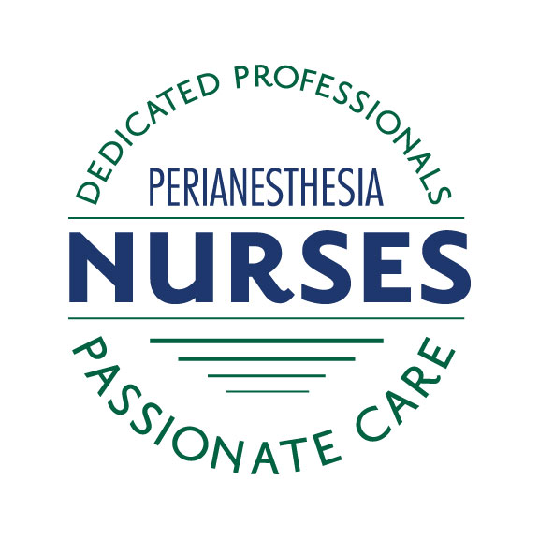

Program Overview

The purpose of this program is to provide educational information to further develop the knowledge base of perianesthesia nurses.

Target Audience

This program is for nurses in all phases of pre and post anesthesia, ambulatory surgery and pain management.

Continuing Education

The application for contact hours is in process through St. Elizabeth Healthcare, an accredited provider through ANCC.

Fun, Fun, Fun

Please join us for the 2022 KSPAN Fall Conference in Louisville, Ky. A continental breakfast, snacks and lunch will be provided during the conference. Registration and breakfast will be served beginning at 7am. A business meeting will take place during the conference for those in attendance. This is a great opportunity for knowledge sharing, fellowship, and networking. There will be door prizes, food, and fun! See you there!

District 1 Education Planning Committee

Teresa Dudley, MSN, RN, CPAN

LaVetta James, MSN, RN, CAPA

Daniel J. Hawkins MSN, RN-BC

Elizabeth Schoulties MSN, RN, NPD-BC, CPAN

**KSPAN BOD**

**Teresa Dudley MSN,RN,CPAN President**

**Elizabeth Steffen, BSN, RN, CAPA President Elect**

**Elizabeth Schoulties MSN, RN, NPD-BC Immediate Past**

**Donna Hagan BSN, RN, CPAN Secretary**

**Pam Malast BSN, RN, CPAN Treasurer**

**Board Members**

**Lisa Casnelli MSN, RN, CAPA, CNOR**

**LaVetta Carney SN-Ed, RN, CAPA**

**Patricia Cooper MSN, RN, CPAN**

**Debra Payne MSN, RN, CAPA**

**Janice Newton MSN, RN**

**Raymond Young DNP, RN, BBA, NEA-BC, CPAN,**

**CAPA**

KSPAN SPRING SEMINAR

October 15, 2022

REGISTRATION – online at KSPAN.nursingnetwork.com

$ 60.00 in person

$ 45.00 Virtual

Registration online at: KSPAN.NURSINGNETWORK.COM

Special Thanks

Norton HealthCare

Miscellaneous

KSPAN reserves the right to substitute speakers if necessary.

You will receive confirmation of meeting registration

Please layer clothing, as it is difficult to maintain a comfortable room temperature for all attendees.

Speaker program handouts will be available for download on the KSPAN web site at www.kspan.nursingnetwork.com