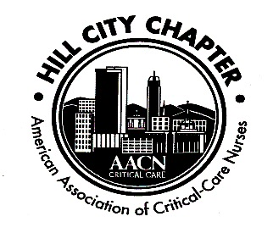 

**Hill City Chapter of the AACN**

**16 July 2020**

1. No official meeting was scheduled.
2. Kriti Erickson, Critical Care Specialist for Medline Industries, INC ( [www.Medline.com](http://www.Medline.com)), sponsored Kristin Jacobs, MSN,MBA,RN,VA-BC, via Zoom, a leading vascular access expert who spoke on PIV Catheters: Stopping the Cycle. “Catheter failures is costly to patients, caregivers and the healthcare system. Even in the most experienced, the rate of peripheral IV catheter failures is 35-50%. Kristin discussed the importance of caring for the peripheral IV and Identifying the appropriate device for each patient

3. Attendees.

a. Maria Scott – Bedford ICU

b. Cheryl Patterson – Cath Lab

c. Anne Marie Caylor, CTICU