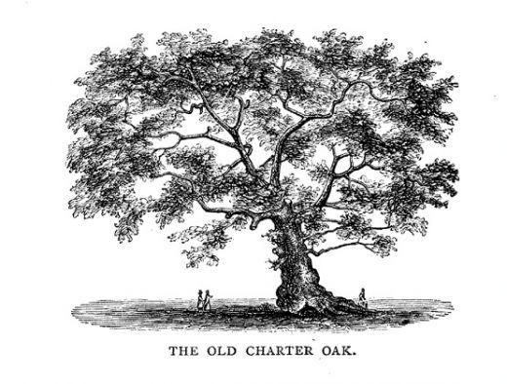

The CT Charter Oak Chapter of the HPNA Presents:

Stress-Suppress-Self Care
Wendy Garvin Mayo, APRN
Date: September 13, 2022
Time: Business MTG 5:45-6pm
Program 6:00-7:00 p.m.

Virtual Zoom meeting
Zoom ID: see page 2 of this announcement

One Contact Hour on completion of evaluation
*No need to be a member to attend*
Target Audience: RN’s, ICU and Med-Surg RN’s and all hospice and palliative staff. Social workers and other allied healthcare workers also welcome

RSVP not required but you can direct any questions to CT.HPNA@gmail.com
Continuing Education credits provided by Middlesex Health


Accreditation Statement: Middlesex Health is accredited by the Massachusetts Medical Society to provide continuing medical education for physicians.
Credit Designation: Middlesex Health designates this live activity for a maximum of 1 AMA PRA Category 1 Credit™. Physicians should claim only the credit commensurate with the extent of their participation in the activity. Middlesex Health designates this live activity for a maximum of 1 Attendance w/ No Credit. Physicians should claim only the credit commensurate with the extent of their participation in the activity.
Series Disclosures: No disclosures.
Event Disclosures: There are no relevant financial relationships with ACCME‐defined commercial interests for anyone who was in control of the content of the activity. Commercial Support: This activity is not commercially supported.

Business meeting and program
Time: Sep 13, 2022 05:45 PM Eastern Time (US and Canada)

Join Zoom Meeting
https://hpna-org.zoom.us/j/89793848571?pwd=NWZnWmVEUnZNdi9UaXpoMU1nMStjQT09

Meeting ID: 897 9384 8571
Passcode: 859807
One tap mobile
+13126266799,,89793848571# US (Chicago)
+16469313860,,89793848571# US

Dial by your location
+1 312 626 6799 US (Chicago)
+1 646 931 3860 US
+1 929 205 6099 US (New York)
+1 301 715 8592 US (Washington DC)
+1 564 217 2000 US
+1 669 444 9171 US
+1 669 900 6833 US (San Jose)
+1 253 215 8782 US (Tacoma)
+1 346 248 7799 US (Houston)
+1 386 347 5053 US
Meeting ID: 897 9384 8571
Find your local number: https://hpna-org.zoom.us/u/kcMz7bVv5

