Fundraiser: Back to school Drive
Please reach out to AORNCT0701@gmail.com with any questions or if you need assistance with collections outside of the Venmo option!
  SCAN HERE | 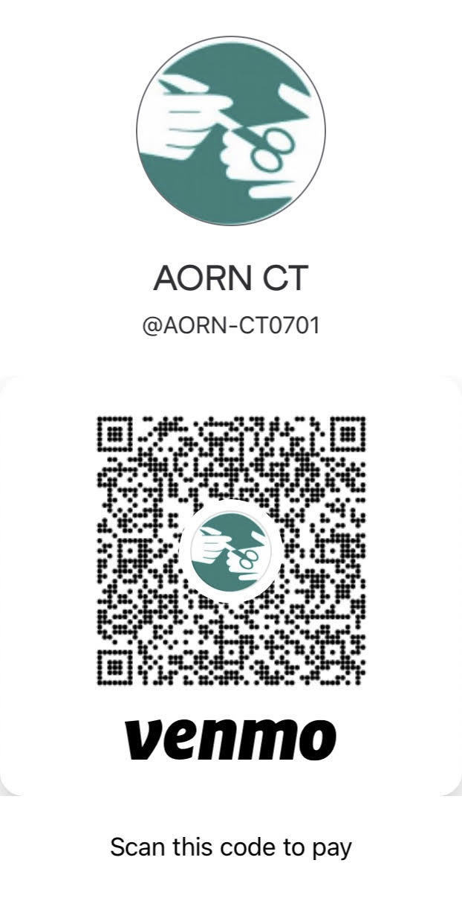 | AORN will be partnering with Salvation Army to collect backpack supplies for back to school!  AORN Chapter is collecting money via cash, check, or Venmo to purchase and fill backpacks for Elementary Students across the Greater Hartford Area  A donation of $25 will fund a filled backpack  Any contribution supports our endeavor for creating a healthy educational environment for growing students.

