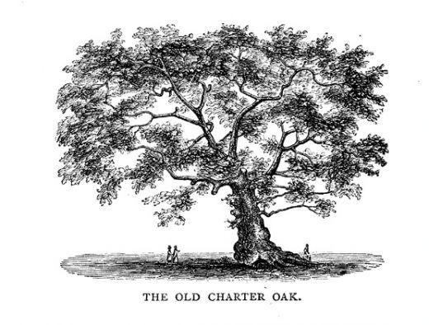

The CT Charter Oak Chapter of the HPNA
Announces
A Free Chapter Membership ($25) Raffle

When you join for the first time or renew your CT Chapter membership, your name will be put into a “hat” and each quarter (see below) one name will be pulled and awarded $25.

July 15 – Oct 15, 2022
Oct 16 – Jan 15, 2023
Jan 16 – Apr 15, 2023
Apr 16 – July 15, 2023

We are open to all Nurses (APRN, RN, LPN) and Nursing Assistants who are interested in quality end of life care for any population. New, seasoned or retired you are welcome. AND STUDENTS CAN JOIN FOR FREE

REMEMBER: you must be a member of The Hospice & Palliative Nurses Association (national organization) to become a chapter member. Not a national member yet? Use the following link to find out all HPNA has to offer.

http://advancingexpertcare.org

