Ballot Candidates 2022-2023

**President-Elect**

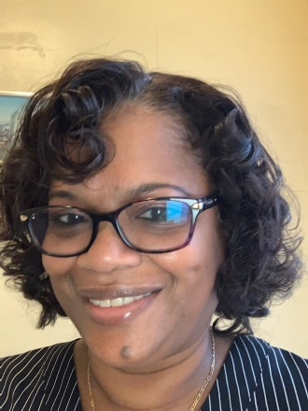

**Dennise Washington, MSN, RN, APRN, ACNS-BC, CCRN**

I have been a nurse for over 35 years, and an APRN for 28. I have experience in Critical and Progressive Care, Emergency/Trauma, education, leadership, and academia. I am currently a Cardiac Clinical Nurse Specialist at Bayhealth where my focus is improving outcomes for cardiovascular patients, primary acute MI. I have been a member of AACN and have been CCRN certified for over 20 years. Additionally, I have been an active member of the Diamond State Chapter for about 7 years and have served on the conference planning committee, participated in multiple volunteer and fundraising activities, and most recently, served as the chapter secretary, from 2020-2021.

As I look back over my career, especially the time during the pandemic, it solidified my passion for Nursing, and nurses. I always knew how important nurses were to the healthcare industry and to each other, but the pandemic solidified what I already knew. During one of the most challenging times of our careers, I saw nurses accomplish what was impossible for most. They put the needs of others first without giving it a second thought. So many made the decision to isolate themselves from their loved ones to keep them safe, while going into a battle with unsure consequences, every day. During that time, I was determined to support nurses in any way I could. Starting now, we can continue to shine the light on the importance of our profession. Starting now, we can make it our business to let every nurse know that he, or she, matter, every day. Starting now, we can be rooted in the fact that we know can overcome anything and move forward into our next, greater chapter. As your president-elect, I hope you will collaborate with me, to do all we can, starting now.

**Secretary-Elect**

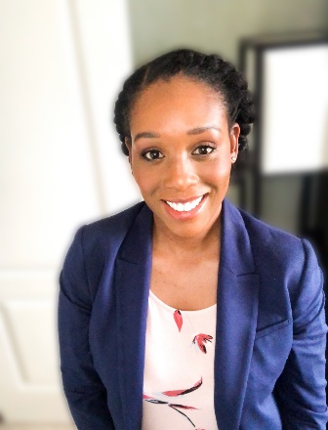

**Loraynne Wilmer, MBA, BSN, RN**

My name is Loraynne Wilmer, and I am a bedside nurse in the Surgical Critical Care Complex at Christiana Hospital. I started my career in the Critical Care Nurse Residency Program, fall of 2020 where I completed rotations on 6 South in Wilmington and in the Neuro and Surgical ICUs in Newark. During my rotations I felt particularly drawn to the patient population I cared for in the SCCC where I was ultimately offered and accepted a position in April 2021. The phrase “Starting Now” is optimistic and speaks to change. For me it means being intentional about my choices related to both career and family life, seeking out opportunities to continue to grow my skills as a nurse, and opening myself up to experiences I may have previously shied away from. In doing those things, I feel I'll be able to better care for my patients, serve my community, provide for my family.

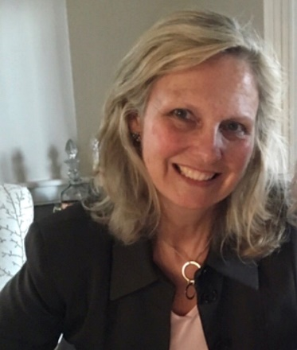

**Karin Cooney-Newton, MSN, RN, APRN, ACCNS-AG, CCRN**

I am Karin Cooney-Newton employed at Bayhealth Medical Center working at both, Kent and Sussex campuses as a Pulmonary CNS. I have 36 years of nursing background, with 34 years of those being in Critical Care. I have never regretted becoming a nurse and find that STARTING NOW we have a perfect opportunity for change to occur to improve our profession, to reach our highest potential and to use our voice to advocate for our underserved populations here in the United States.

**Treasurer-Elect**

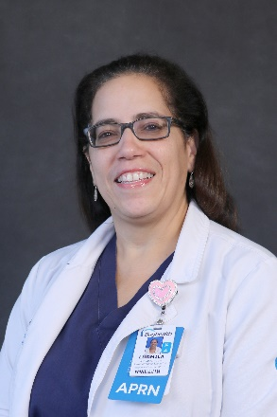

**Ludmila Santiago-Rotchford, APRN,MSN,PCCN,ACNS-BC**

I am a Cardiac Clinical Nurse Specialist at Bayhealth and have been in the CNS role for 15 years. I have been a member of AACN since 2007 and longtime member and past president of the Diamond State Chapter. Starting NOW we need unite as the only chapter in Delaware to motivate and lift up each other's spirits so we can get back to the nurturing part of Nursing.