Minnesota sgna Spring newsletter 2022

**President’s Corner**

Hello MnSGNA members!!

The St. Luke’s winner of our SGNA membership to celebrate Gi Nurse and Associate week was Jennifer Serafin.

She is an amazing nurse in our endoscopy unit. She is certified and is excited to have more access to education with her new membership.

Jenn is an amazing team member who is always willing to help others and be supportive to her co-workers and her patients. Congratulations Jenn on your membership!!

Happy Spring—well, this is Minnesota—so I guess this is our “Spring Surprise” weather.

Are you ready to be done with winter? I must confess that I am ready for warmer weather and summer/spring sunshine and warmth. Spring also brings the promise of new opportunities. New opportunities in every aspect of our world. For MnSNGA and SGNA it is the hope, and reality, of in-person conferences.

SGNA is having the national conference IN PERSON! That is a new adventure considering the last few years of chaos we have all experienced. I confess I enjoyed the virtual conferences. I could always hear the speakers, could review the content for better understanding and still listen to the questions and comments. However, I did miss the networking and hands on experiences that happens at the in-person conferences. There’s a connection between thousands of GI people that gather to expand their knowledge of their profession.

The national conference is an amazing educational event to meet others from near or even international places. This year SGNA National conference will be held in Salt Lake City, UT. Pre-conference is May 20-21, Conference is May 22-24. They will also have a virtual conference on June 3-4. Explore the website for the details and information needed to join your GI colleagues for some fun and excitement—oh yes—and LEARNING!! We hope to see you there! Our board member, Karin Cierzan, will be one of the presenters at the conference.

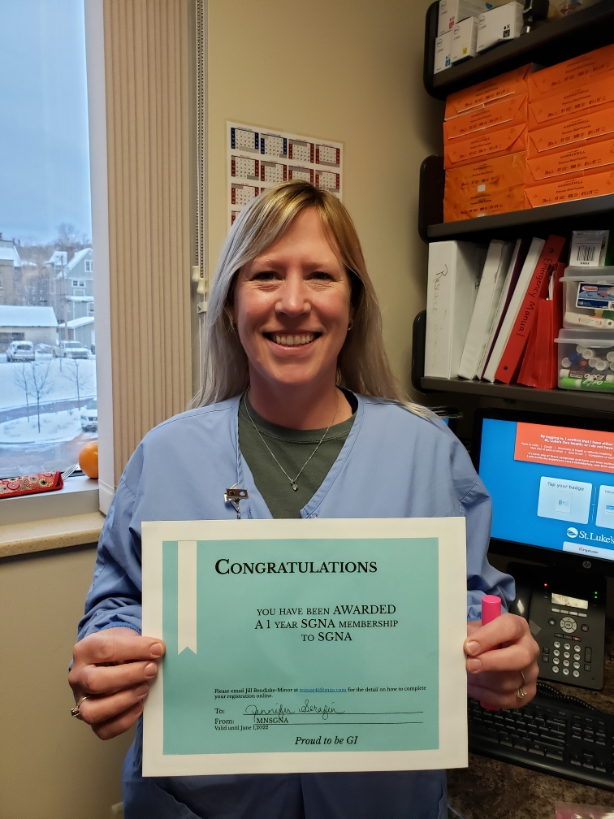

Your board has been very busy these last few years attempting to have conferences, virtual experiences and creative ways to get education to the members. We are planning, at this point in time, to have the fall conference in-person! So please save the dates—October 15 & 16. Watch your emails for more exciting information. If you are not able to travel to Salt Lake City-we hope you choose to travel to St Cloud for the fall conference.

Thank you for your patience with our many attempts at having a conference. Thank you for the difficult work you have all been through, and continue to work through these past few years. Nothing like a pandemic to give more challenges to cleaning, our safety and patient safety, continuing to learn new techniques and equipment with limited contact with our vendors. Appreciation and gratitude come to mind for me. I know I have always had appreciation and gratitude. However, this pandemic might have helped us all remember to cherish and appreciate what we have, who we work with, and how important smiles and personal contact means to our human world. We may have simplified some areas of our lives. We may have decided to cherish time at home and with close friends and family

I look forward to more meetings in person. We look forward to more education events together. I hope to meet you at a conference soon. Share your GI passion experiences with me. Enjoy your summer! See you soon—maybe at a conference in the fall?

Respectfully submitted,

Vicki Johnson, RN, CGRN President MnSGNA

It's hard to believe that 3 years have passed since our last in person SGNA Annual Course. I discovered wonderful coffee shops in Portland, especially Stumptown Coffee. I was meeting friends for breakfast and was dropped off in the wrong location. I turned around and there was Stumptown Coffee. I bought 2 bags to bring home. I was thrilled to find out that their whole bean coffee is available at grocery and retail stores here in the Twin Cities.

Even though I am looking forward to attending classes, networking and presenting at the annual course, I do plan on getting that perfect cup of coffee to start my day. From Sugar House Coffee to Nostalgia Cafe to Coffee Garden, the possibilities are endless.

I hope to see many of you in Salt Lake City!

Karin Cierzan, RN CGRN CRNI

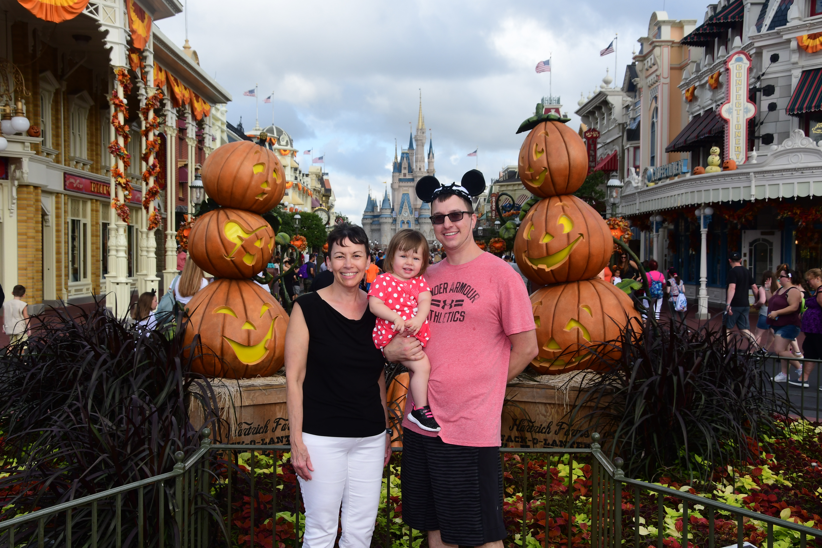

I remember the time I was asked to join SGNA, I was so nervous. It was one of the best decisions I made. I have met many friends, able to go to several conferences and learn so much about GI.

It is not a huge commitment so if you are thinking you would like to be more involved, this would be a great way to start! A great way to start would be volunteering to assist with the fall conference.

Email us at [mnsgna@gmail.com](mailto:mnsgna@gmail.com)

Laura Danner, secretary

as of may 24th when the annual course concludes, karin cierzan, rn cgrn crni, will be president of abcgn. Please join us in congratulating her, we are so proud of her!

St. Cloud Hospital SGNA Week Celebration 2022

At the St. Cloud hospital Endoscopy unit, we are always excited to celebrate Gastroenterology Nurses and Associates Week. We look forward to this every year, and this year was no different. We knew that after two years of not being able to celebrate the way we were accustomed, this year we were going big. We started planning in full anticipation of being able to gather without fear. We also knew that our teammates needed this celebration to refresh, renew, and find hope. Each day was divided into an activity, with the final celebration on the last day.

Day one- Teammates were given appreciation cards that they colored for each other and displayed throughout the unit. These signified our appreciation for each other and realize we need each other to fully engage and serve our communities in the most effective way possible. Personally colored notes of appreciation formed the backdrop for our beautifully decorated department. Additionally, to represent colon cancer awareness month, we displayed names of colon cancer survivors on blue ribbons that adorned the Endoscopy department walls.

Day Two- We handed out a crossword puzzle that brought out our competitive nature. Everyone was gleaning for that ultimate prize drawing of local gift cards. The crossword was all GI-related knowledge, so our team was able to learn from this activity as well. in addition to that, large puzzle pieces with teammates' pictures on them were hidden throughout the unit. Everyone likes a good scavenger hunt. Once found, the puzzle piece were displayed on the wall in the form of a heart. The heart shape represented our unrelenting quest to start each day with a grateful heart for each other and with our patients.

Day Three- Our break room was filled with grab-and-go snacks. These were team members' suggestions, so we knew they represented the specific snacks they wanted.

Day Four- We announced the one-year membership to SGNA, and Jeryn Sia Su was the name drawn. Jeryn was so appreciative and could not be happier. She is new to the GI unit and is excited to develop her GI knowledge and set goals consistent with SGNA's mission and purpose. We couldn't have a more deserving individual. Day 5 was desserts all day, and the highlight of the week was a personal coffee barista who came to our unit worth her coffee cart to provide signature coffee to all teammates. This was all made possible by teammates who believed in our mission and purpose, each taking a vital role in creating the fun-filled week. We are already looking forward to next year's celebration.

Respectfully submitted; St. Cloud Hospital Endoscopy Staff

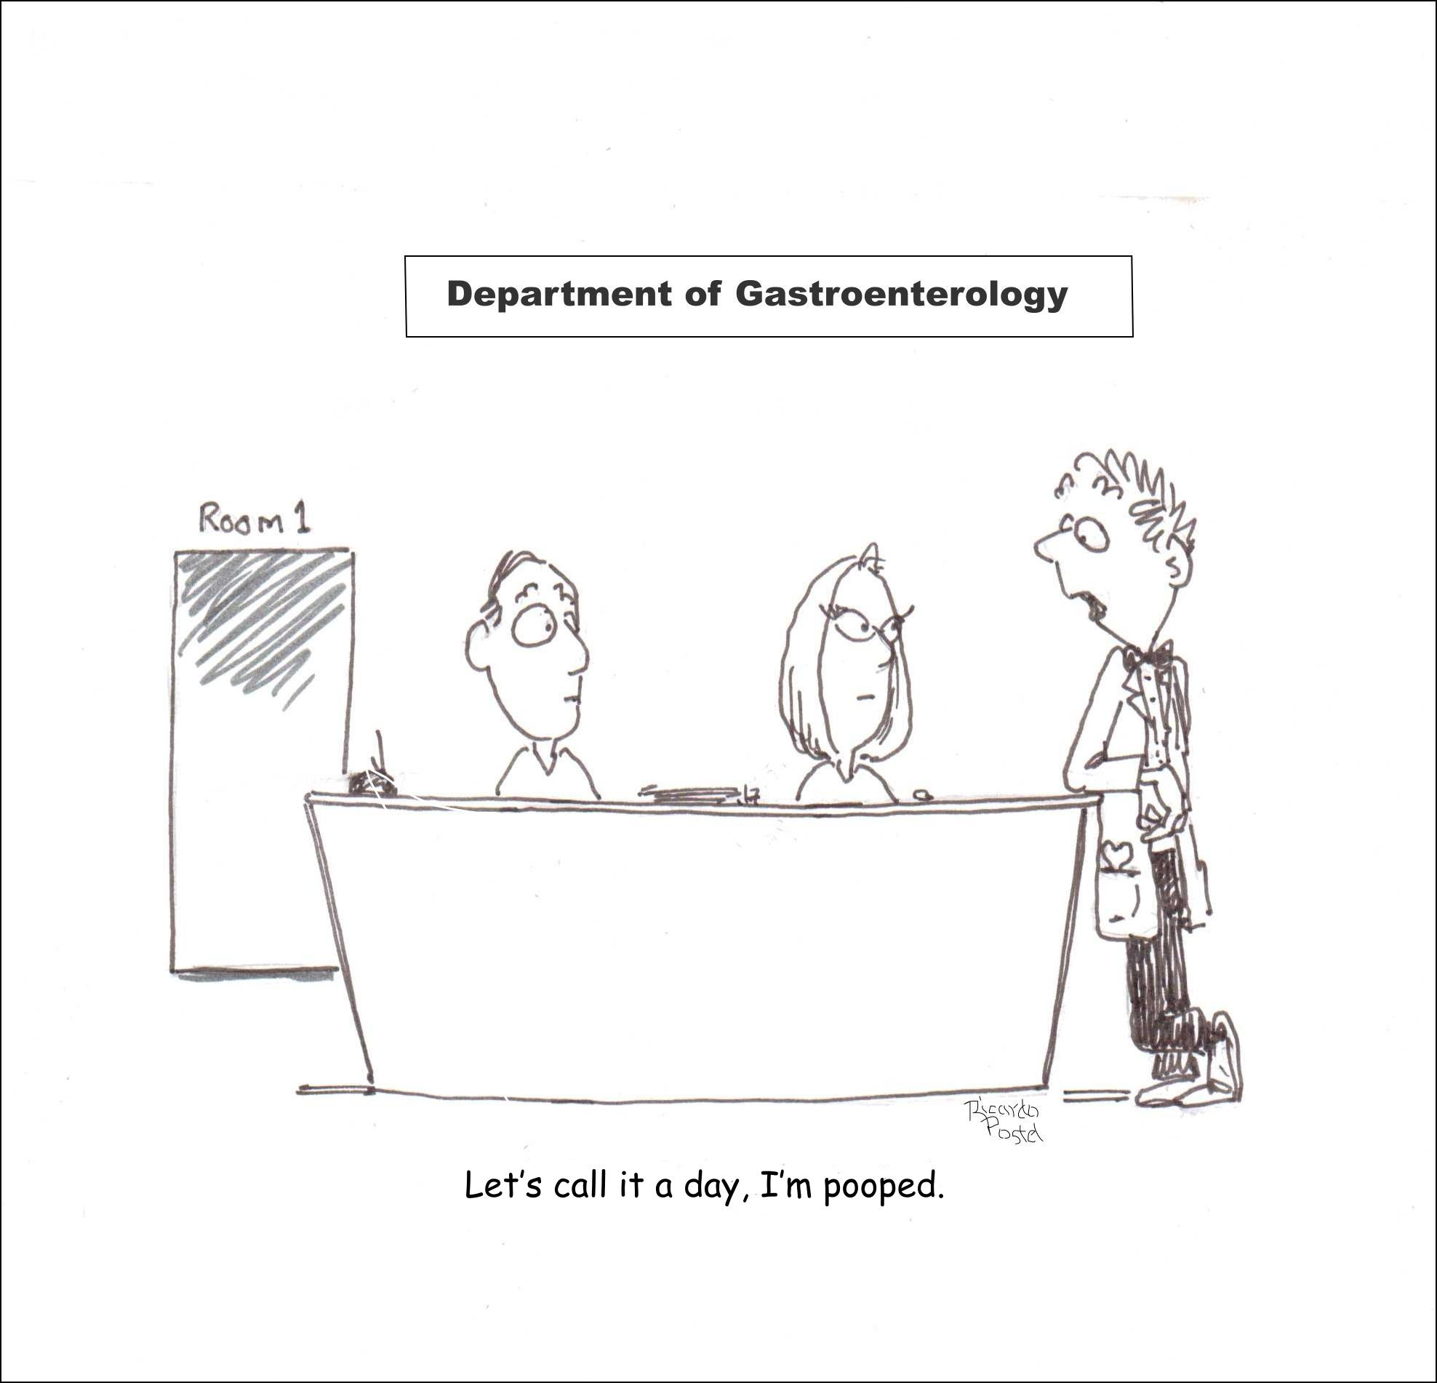

Up coming events:

May 11th Boston Scientific Event

October 15th,16th 2022 Fall Conference

St. Cloud Park Event Center

SGNA Annual Conference In Utah

Looking for social/networking event for Saturday night after fall conference. We would love to

hear any of your suggestions! Please email mnsgna@gmail.com