Finger Lakes Region Chapter of HPNA

Voluntarily Stopping Eating and Drinking at the End of Life

Jessica Luciano, NP
Palliative Care Nurse Practitioner Wilmot Cancer Institute

June 27, 2022
Join Zoom Meeting (right click and then click on Open Hyperlink)

Rochester, NY 6:00 – 7:00 PM

At least 80% of participants will state that this activity validates, enhances, or will change practice related to caring for patients who voluntarily stop eating and drinking at the end of life.
Karen Abbas MS RN AOCN NPD-BC karenabbas@gmail.com

No registration required, event is free of charge

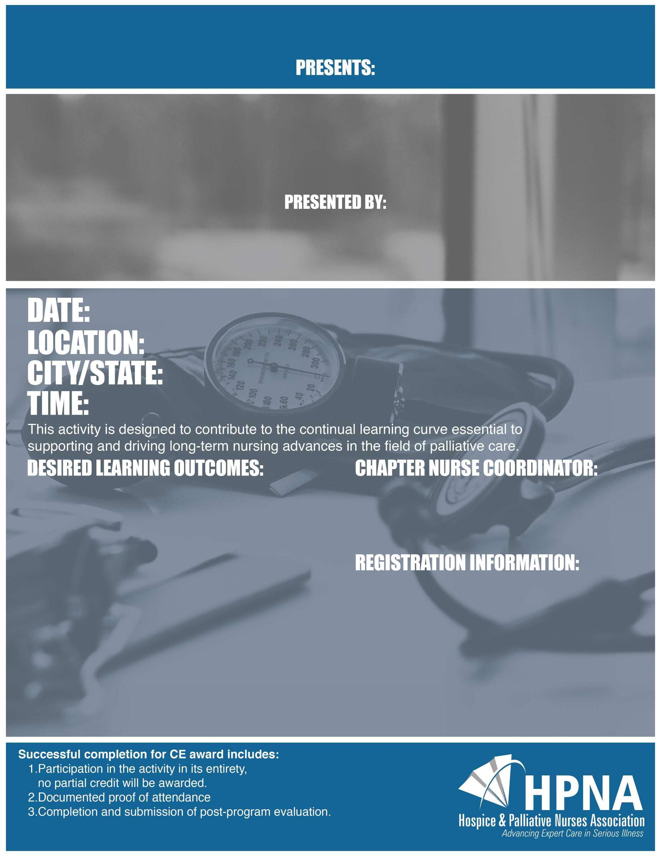

This activity has been submitted to the Hospice and Palliative Care Nurses Association (HPNA) for approval to award 1 contact hours The Hospice and Palliative Nurses Association is an approved continuing education provider (CEP) by the California Board of Registered Nurses Provider Number 7976.

This course is offered to all interested participants as a continuing education service with no course attendance fee*.

