Celebration of Lois Schick’s amazing life!

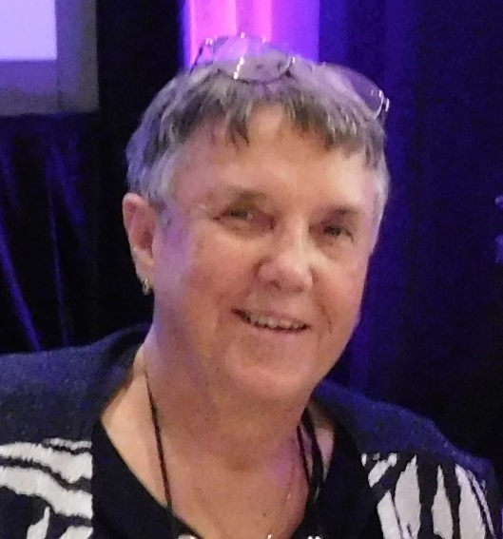
Saturday June 4, 2022
1-5 PM
Washington Park
S Downing Street-2 blocks north of I-25
Southwest end of the park near the tennis courts
Bring a picnic, something to sit on,
lawn games or
just drop by
Questions?? Nancyo44@aol.com or 303-437-5546

