AORN: Fort Worth Chapter #4406

General Membership Meeting

Thursday 4/28/2022 @ 7:15pm

Directions:

*\*meet at Camelot Court by 7:15pm for guided tour to Decker Board room*

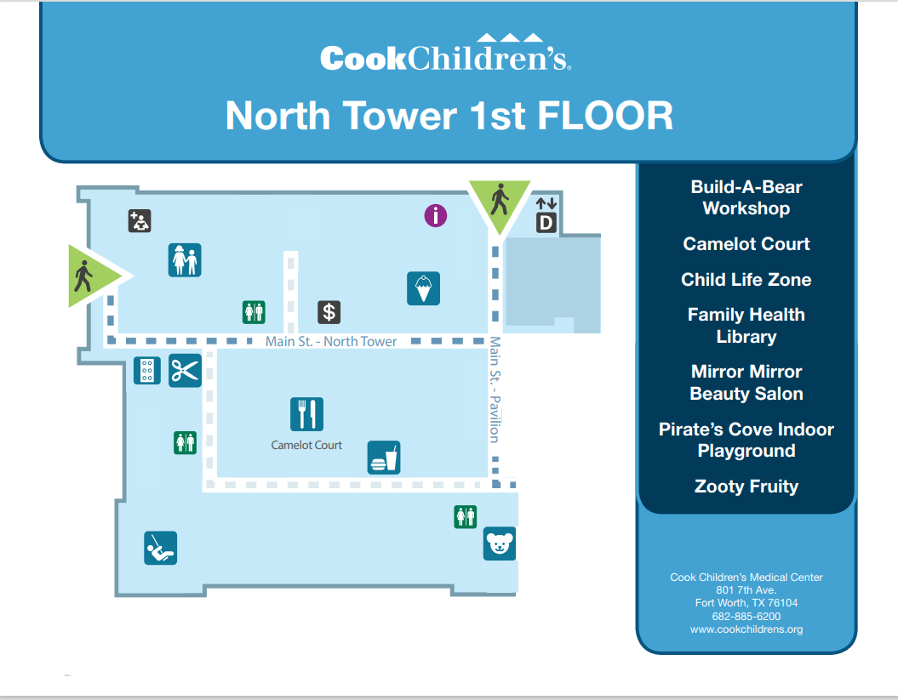

**Meeting info: Location= *Decker Board Room*~ basement level under the staircase.**

***Parking = 7Th Ave. Garage***

