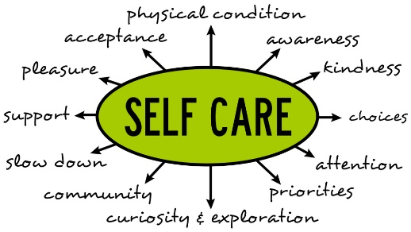

Take Care of Yourself – American Nurse

March, 2022

Dear NYONEL Member

In the New York State Nursing Executives and Leaders (NYONEL) November Newsletter, the NYONEL Research Committee indicated their intent to survey the membership regarding self-care. The Committee is focused on this topic as nurse leader self-care is positively related to strengthening and maintaining resiliency and wellness among the healthcare staff they serve because caring for self-first enables the nurse leader to better care for others. Specific to nursing leadership is the stress of competing priorities ranging from patient outcomes to staff satisfaction. The current COVID 19 pandemic has created additional stress on healthcare systems with high numbers of acutely ill patients, particularly for nurse leaders.

Strategies to reduce stress among nurses is to practice self-care; however, little is known about the current practice of nurse leaders with regard to self-care. The purpose of this study is to assess the self-care practices of NYONEL membership (n=533) which includes nursing leaders in all practice areas, academia and research. This prospective, cross sectional, descriptive study will use the Self-Care Practices Scale; a validated, self-report, 18 item Likert scale questionnaire designed to assess both the frequency of personal and professional self-care (0=never to 4= very often). All NYONEL members are strongly encouraged to participate! The link below will take you to the survey and demographic tool. The survey is exempt from human research per the University of Rochester IRB. Completion of the survey tool implies consent. All data will be reported in the aggregate and shared with the NYONEL membership in the Fall of 2022.

**Survey link:** [**https://www.surveymonkey.com/r/8DJFT9W**](https://www.surveymonkey.com/r/8DJFT9W)

If you have questions or concerns please feel free to contact either Linda Millenbach by e-mail at [lmillenbach@icloud.com](mailto:lmillenbach@icloud.com) or Kathleen Sellers @ [sellerk@sunypoly.edu](mailto:sellerk@sunypoly.edu).

Thank you for taking the time to complete the survey on this important topic. **The deadline to complete the survey is April 30, 2022**.

NYONEL Research Committee

**Members**  **email address**

Mary G. Carey mary_carey@urmc.rochester.edu

Cathy DeChance CDechance@excelsior.edu

Lillian Diaz Lillian.Diaz@nychhc.org

Paula Graham grahamprn@gmail.com

Linda Millenbach [lmillenbach@icloud.com](mailto:lmillenbach@icloud.com)

Jeanmarie Moorehead Jeanmarie.Moorehead@nyulangone.org

Kathleen Sellers sellerk@sunypoly.edu

Mary Zajc mary.zajc@gmail.com