Nursing and the use of Simulation!

Hear the latest from the Annual International Meeting on Simulation in Healthcare (IMSH), and simulation use at the WSON at SJFC!

Joanne Weinschreider MS, RN

Sponsored by NACNS-WNY chapter

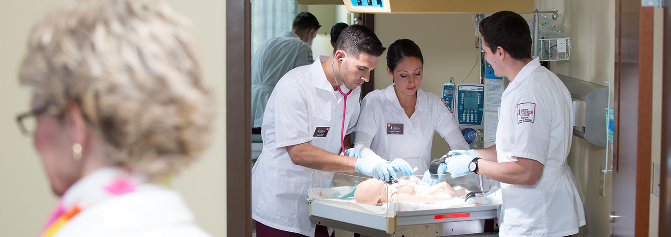

Join us for our virtual April meeting!

Monday, April 25th

Via Zoom, Link to follow

RSVP with your email address to Eileen Wilbert: [ewilbert@sjfc.edu](mailto:ewilbert@sjfc.edu)

Members of NACNS-WNY: free to attend

Nonmembers: $5.00

Mail check to: Eileen Wilbert, 5211 County Line Road Webster, NY 14580

4:45pm-5pm: Business meeting

5pm-6pm: Presentation

6pm-6:15pm: Electronic Evaluation

1 ceu pending approval