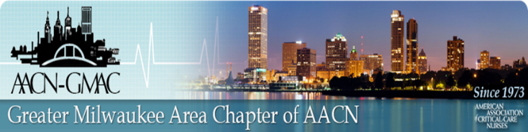

**Virtual Education Session**

**April 19, 2022**

**ECMO and The COVID Patient**

by:

Jennifer Guy and Amber Stempf

Program:

7:30 p.m. AACN-GMAC Welcome and Announcements

7:35 p.m. Presentation

**This is a FREE event. All participants need to register for zoom link:**

[*https://us02web.zoom.us/webinar/register/WN_oeF5mxD8RjytPpOgbMIPog*](https://us02web.zoom.us/webinar/register/WN_oeF5mxD8RjytPpOgbMIPog)

*Link for evaluation and CE will be provided after the session.*

Objectives:

Differentiate the different types of ECMO support.

Verbalize indication for COVID patients to receive ECMO.

Discuss plan of care for COVID patient receiving ECMO.